Curiosity-driven learning in adults with and without dyslexia

Bethany Garvin and Saloni Krishnan
Department of Psychology, Royal Holloway, University of London, Egham Hill, Surrey TW20 0EX

Abstract

People are willing to spend time and money to receive information and content they are curious about, such as answers to trivia questions, suggesting they find information per se rewarding. Further, in neurotypical adults, states of high curiosity, and high satisfaction with the information received, are known to enhance learning and memory of information encountered in that state. Here, we ask whether the relationship between curiosity, satisfaction, and learning is altered in a group with specific learning difficulty with reading (dyslexia). Using the willingness-to-wait paradigm, we observed that adults with and without dyslexia are willing to spend time waiting for verbal and visual information. This indicates that the same “wanting” mechanisms are seen in individuals with dyslexia for information. We then examined whether information that was desirable was also associated with enhanced memory. Our findings indicate that information does function like a reward, with the gap between expected and received information driving memory. However, this memory effect was attenuated in individuals with dyslexia. These findings point to the need to understand how reward drives learning, and why this might differ in dyslexia.
Curiosity-driven learning in adults with and without dyslexia

Curiosity for ideas or knowledge is referred to as epistemic curiosity, and this form of curiosity is a powerful driver of learning. In schools, teachers encourage such curiosity from a young age, as the drive to learn new information is thought to be linked to academic achievement (von Stumm et al., 2011), and achievement in the workplace (Reio & Wiswell, 2000). Curiosity has also been linked to academic persistence, question asking, and willingness to spend resources on learning (Grossnickle, 2016). Additionally, studies have demonstrated that the intrinsic desire to seek new information is also linked to improvements in learning and memory (Kang et al., 2009). Understanding epistemic curiosity could therefore have powerful implications for classroom practice, and this might be important when designing learning programmes for those with learning disorders such as dyslexia. Individuals with dyslexia are known to have difficulties learning, particularly when information is verbal in nature. However, it is not clear how curiosity might interact with learning and memory in this group – do those with dyslexia express the same level of curiosity for information? Do they get the same curiosity-driven memory benefits as neurotypical adults? Is this benefit equivalent for visual and verbal tasks? Here, we focus on how states of curiosity about visual and verbal material affect learning and memory in adults with literacy difficulties.

While previous educational research largely focused on curiosity as an trait that individuals possessed, more recent research points to how states of epistemic curiosity influence learning and memory (reviewed in Grossnickle, 2016). The link between states of high epistemic curiosity and enhanced memory has now been comprehensively demonstrated in multiple studies (Brod & Breitwieser, 2019; Fandakova & Gruber, 2020; Gruber et al., 2014; Halamish et al., 2019; Kang et al., 2009). In one of the early demonstrations of the role of states of curiosity on memory, Kang and colleagues (2009) found that participants were more likely to remember answers to trivia questions they expressed curiosity about, even 11-16 days after learning. Indeed, heightened states of curiosity can even lead to better encoding of incidental information, such as faces presented interspersed between a trivia question for which curiosity is expressed, and the answer (Fandakova & Gruber, 2020; Gruber et al., 2014). At the neural level, curiosity appears to enhance learning through increased dopaminergic modulation of hippocampal activity. High epistemic curiosity is associated with functional activity in areas typically associated with reward-processing, such as the caudate nucleus, as well as the midbrain and ventral tegmental area (Kang et al., 2009; Lau et al., 2020). In turn, curiosity-driven memory benefits are associated with increased midbrain-hippocampus functional connectivity (Gruber et al., 2014). This indicates that curiosity can act as an index of intrinsic motivation for learning, or an anticipation of reward.

Although definitions of epistemic curiosity can vary considerably across studies (Grossnickle, 2016), recent conceptualisations have viewed this form of curiosity as a gap in knowledge, leading to a drive to acquire new information and resolve uncertainty. For instance, the PACE (prediction-appraisal-curiosity-exploration) framework of curiosity (Gruber & Ranganath, 2019) postulates that curiosity is triggered by prediction errors, which indicate that information may have value in the future. This framework suggests that curiosity-based prediction errors trigger enhanced memory encoding, through increases in attention, arousal, and information seeking, as well as enhancing the consolidation of the received information. The underlying premise is that receiving information, or alternately, resolving informational uncertainty, is inherently rewarding (Bromberg-Martin & Hikosaka, 2009; Bromberg-Martin & Monosov, 2020; Charpentier et al., 2018; FitzGibbon et al., 2020). Supporting this theory, Marvin and Shohamy (2016) demonstrated that information that elicited greater curiosity was also associated with greater waiting times in a willingness-to-wait paradigm, where waiting was used a measure of intrinsic reward. Considering information as reward also suggests a parallel with the reward-processing literature, where the discrepancy between expected and received reward (reward prediction error) is associated with learning. This framework has recently been extended to examine how the discrepancy between the value of expected and received information, or an “information prediction error” (IPE), might influence learning. Positive information prediction errors, or instances when satisfaction with information received exceeds initial curiosity, are associated with better memory in adults (Marvin & Shohamy, 2016), as well as in children and adolescents (Fandakova & Gruber, 2020). This indicates that it is not merely curiosity, but also satisfaction with the information received, that drives learning. Indeed, this indicates a new PACE cycle is started when information is received, generating prediction errors that can further benefit memory (Gruber & Ranganath, 2019).

Investigating the role of states of curiosity during learning in those with dyslexia may shed light on how to better design programmes for those with specific learning difficulties, especially as states of curiosity might be malleable, and offer opportunities to enhance learning (Stahl & Feigenson, 2015; Subbotsky, 2010). Dyslexia is a neurodevelopmental disorder characterised by difficulties with reading, particularly decoding text. The prevalence of dyslexia is estimated at between 3-7%, and dyslexia is associated with a higher risk of academic difficulty, mental health problems, and underemployment (Wagner et al., 2020). Individuals with dyslexia are known to read less: having a reading disorder has been linked to reductions in lifetime exposure to books and print (Snowling et al., 2007). This decrease in voluntary reading is thought to stem from lifelong difficulties with reading (van Bergen et al., 2018). Those with dyslexia have been also shown to have difficulties learning semantic information, particularly when this information is verbal in nature. Learning difficulties are less marked in the visual domain (Alt et al., 2017; Clayton et al., 2018). For instance, in a paired associate learning tasks, children with dyslexia performed well when they learned visual-visual mappings, but demonstrated impairments for learning verbal-visual or verbal-verbal mappings (Litt & Nation, 2014). To date, relatively little research has focused on assessing intrinsic motivation for semantic information in those with dyslexia. One study has shown self-reported curiosity for reading is diminished in poor readers in childhood (McGeown et al., 2012). Yet, it is unclear if by adulthood, intrinsic epistemic curiosity will differ in those with dyslexia, because of their long history of reading difficulty. In other words, do adults with dyslexia experience the same level of curiosity, and satisfaction with verbal material, as neurotypical individuals? If not, is curiosity dampened for verbal material specifically? Does the relationship between curiosity, reward, and memory differ in those with reading disorder?

Here, we assess epistemic differences in curiosity for verbal and visual material that taps semantic knowledge. We ask if adults with dyslexia present with different levels of intrinsic curiosity for these two types of material, and whether they show the same willingness to wait for information as neurotypical adults. We then investigate whether curiosity and IPE are associated with better memory, and if this relationship holds for those with dyslexia.

Methods

Participants
Our aim was to collect a minimum of 30 complete datasets in each group. A formal power analysis was not conducted, rather, this was the maximum number feasible with available funding. This sample size was also in line with or larger than other studies examining the effects of curiosity on learning (Kang et al., 2009; van Lieshout et al., 2018).

We recruited a total of 62 participants for this study (31 controls [Age M=28.26, SD=5.37, 11 females]; 31 adults with dyslexia [Age M=26.06, SD=6.06, 13 females]). Participants were recruited via the participant platform Prolific. Participants were between 18-40 years of age and spoke English as their first language.

We initially invited participants to complete a screening session, where they completed demographic information including whether they had received a diagnosis of dyslexia or any other neurodevelopmental disorders. To identify controls, we invited participants who answered “no” to the Prolific screening question “Literacy Difficulties”. To identify participants with dyslexia, we invited participants who answered “yes” to the Prolific screening question “Literacy Difficulties”. The rationale for further screening was to ensure that participants with a self-reported history of dyslexia did have a history of reading difficulties (rather than spelling difficulties for instance), and in addition, that their reading challenges were persistent at the time of testing. All participants were consequently asked to complete two brief tests. The first test was the Abbreviated Adult Reading History Questionnaire or ARHQ-Brief (Feng et al., 2020), which is a questionnaire that allowed us to ascertain whether participants had faced reading difficulties in childhood. The second test examined participants’ sentence verification ability, which was an objective task to allow us to assess reading fluency and comprehension. Both measures are described in more detail in the materials section below).

Controls were deemed eligible to participate when they reported no neurodevelopmental disorders during screening, and when they scored <.32 on the AHRQ-Brief. We also calculated a z-score on the sentence verification task described below, participants were required to have a z-score > -1 (norms based on performance of 100 controls). We screened 100 participants, of which 73 were eligible to participate. Eligible participants received an invitation to participate in the new study; the first 31 participants to respond were recruited into the second phase.

Participants with dyslexia were deemed eligible to participate on the basis of a self-reported diagnosis of dyslexia, an AHRQ-Brief score of >.32. We calculated a z-score on the sentence verification task described below, participants were required to have a z-score of -1 and below to participate. We screened 149 participants, of which 66 were eligible to participate. We issued an invitation to all 66; the first 31 participants to respond were recruited.

One adult with dyslexia did not complete the memory task on Day 2.

Materials

The task was presented using www.gorilla.sc, an online experiment platform (Anwyl-Irvine et al., 2020). Access was restricted to those playing using tablets and computers.

Screening measures

AHRQ-Brief
The ARHQ-Brief is a 6-item self-report questionnaire which is a quick and efficient way to assess adults’ reading history. Items included whether participants had difficulties learning to read in primary school, or if they reversed the order of letters or numbers. A previous study has shown that this measure is strongly correlated with a composite reading ability score (Feng et al., 2020). The same study determined that the optimal ARHQ-Brief threshold was .32, with scores greater than this indicating that adults were likely to be poor readers (sensitivity 72.4%; specificity 81.5%).

Sentence verification task
Those in the dyslexia group self-identified as facing literacy difficulties. We developed a sentence verification test to objectively assess participants’ reading comprehension ability (reading fluency and decoding). This test comprised 80 sentences. Participants were given 90 seconds in total to read and verify the truthfulness of these sentences, based on real-world knowledge (for instance, “All birds are blue”). Each sentence only stayed on screen for 3 seconds. Participants received 1 point for each sentence they correctly verified, with a maximum possible score of 80. The task can be viewed on Gorilla Open Materials (https://app.gorilla.sc/openmaterials/237000).

To construct sentences for the sentence verification task, we developed a pool of key words. These words were drawn from the MRC Psycholinguistic Database, based on several characteristics: age of acquisition, concreteness, familiarity, imageability and written frequency. These key words were assigned to one of five blocks, with later blocks containing more challenging words. Sixteen sentences were generated per block (Sentences used in the task are available on the OSF, see https://osf.io/j6fp4/). Each sentence contained a maximum of 2 key words, and words were not repeated. Sentence length also increased across the five blocks. Consequently, over the course of the task, we expected the sentences to become more difficult to read.
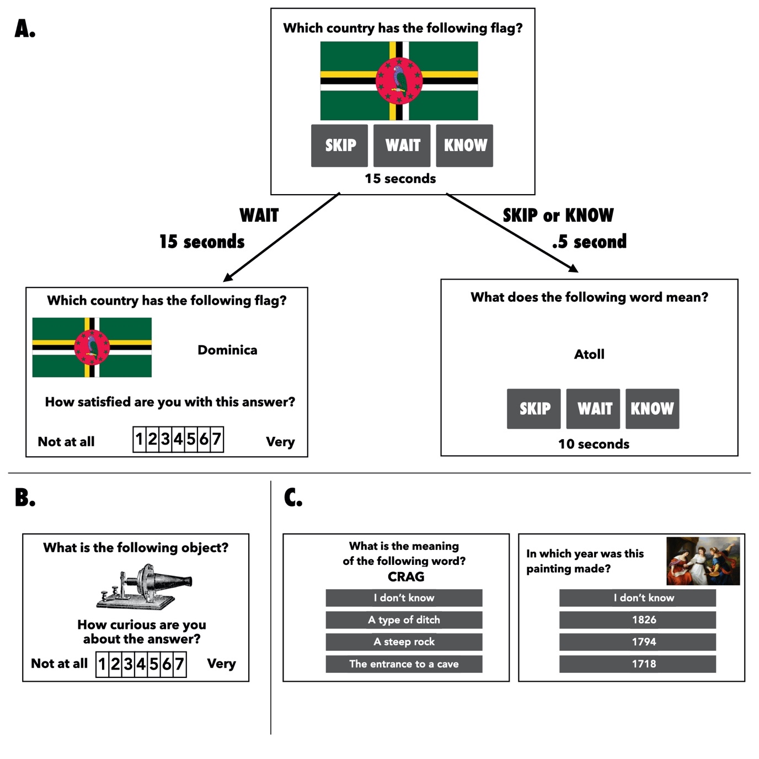

Figure 1. Experimental paradigm. Panel A shows the willingness-to-wait task, where participants were shown a question and three possible choices. If participants chose “Wait”, they waited for the amount of time displayed alongside the trial, and were then shown the answer. They then rated their satisfaction with the answer. If they chose “Skip” or “Know”, they advanced to the next trial after a brief pause of 500 milliseconds. Panel B shows the curiosity task participants completed after the willingness-to-wait task. Participants rated all the questions they encountered using a 7-point scale (1- Not curious at all, 7 – Very Curious). Panel C shows example trials from the memory task that participants completed on the next day (one visual and one verbal question are shown). Participants were given an “I don’t know” option, in addition to the correct answer, and two closely related semantic lures.

Experimental Tasks

We first describe the stimuli used, which were common to all experimental tasks, followed by the design of the three experimental tasks.

Stimuli
Stimuli were chosen to tap visual or verbal semantic knowledge. In a piloting phase, we established that that neurotypical adults (N=30) scored <20% accuracy for each item chosen. We also established that curiosity and satisfaction ratings showed similar distributions for the visual and verbal stimuli in this piloting phase.

For verbal stimuli, we chose 60 unusual words (for example, “atoll”). The words selected were either a noun or an adjective – no verbs were included. Each word was paired with a definition taken from the Cambridge Dictionary (https://dictionary.cambridge.org/). Definitions were shortened to eliminate any examples given and to ensure that no definition exceeded 15 words. As an example, the definition of atoll was “A ring-shaped island formed of coral”. Items were selected from a range of themes (science and medicine, geography, history, art and music, general knowledge and media) to help ensure a spread of curiosity ratings across individual.

Visual stimuli were drawn from the same themes as the verbal stimuli. The visual stimuli were trivia-based questions with a visual element to the question. For example, “Which country has a particular flag?”. We chose 60 items in total.

The questions are openly available on Gorilla (https://app.gorilla.sc/openmaterials/237000).

Willingness to wait task
In this task, participants were presented with the 120 trivia questions described in the stimuli section (see Figure 1A for a trial schematic). The presentation of visual and verbal questions were interleaved in blocks of 8 (4 visual/ 4 verbal), to ensure that participants did not see one type of stimuli excessively at any point in the experiment. Within each block, the presentation of items was random. Participants had a maximum of 10 seconds to read the question and choose their response. They were provided with three response choices, Skip, Wait and Know. If they already knew the answer, they were instructed to press the Know key. They were instructed to press Skip if they did not know the answer, but weren’t interested in finding out the answer, or weren’t willing to wait the amount of time designated by the Wait option. After a brief fixation, both the Skip and Know responses were followed directly by the next question. Participants were instructed to press the Wait button if they did not know the answer, and were interested in finding out the answer, as well as willing to wait the amount of time designated. The time delays associated with the Wait option varied, in 5-s increments, from 10 to 30 s (the time delay associated with each item was counterbalanced across participants). Upon choosing the “Wait” option, participants saw a fixation cross for the duration of the wait time, and then the answer appeared. Once they chose to wait, they could not change their choice. Participants were then asked to rate their satisfaction with the answer, on a scale from 1 (Not satisfied at all) to 7 (Very Satisfied).
Curiosity ratings

Participants were shown the same 120 questions they encountered in the willingness-to-wait task and were asked to rate their curiosity upon first seeing each question. They responded on a scale from 1 (Not at all curious) to 7 (Very curious); see Figure 1B. The questions were randomly ordered.

Memory task

For use in the memory task, we created two alternate definitions (lures) for each word or visual item. The lures were written to match the same theme as the target word. Particular care was taken to ensure that lures did not represent any definition similar to that of the target word to avoid confusion. For each target word the fourth option was ‘I don’t know’.

The memory task was completed at least 24 hours after the session on the first day. Participants saw the same 120 questions they’d seen the previous day and selected the answer to each question. If participants picked the correct definition/ target, the item was scored as accurately remembered.

Procedure

As described above, a large pool of participants were initially screened using the AHRQ-Brief questionnaire and the sentence verification task. Once participants completed the screening phase, eligible participants were invited to participate in the experiment via Prolific. They were informed the study involved 2 parts. However, they were not given any details about what was involved on the second day.

On the first day, participants provided informed consent. They then completed the willingness-to-wait task. Participants were instructed that the entire task was expected to approximately 45 minutes; however, in reality, the task was not timed in order to allow participants to experience all the items. We embedded three attention checks in the willingness-to-wait task, i.e. a rating scale where participants were instructed to press a specific button. We planned to exclude participants who did not pass all three attention checks; no participant was excluded on this basis. Trials where participants did not respond using the 3 options within the specified time window (10 seconds) were also excluded.

After the willingness-to-wait task, participants provided their ratings of curiosity. Participants were sent a link to complete the memory task approximately 24 hours after their first session.

Analysis

All analyses were performed using R (R Core Team, 2020). Mixed effects logistic regression models were conducted using the lme4 package (Bates et al., 2014). Plots were generated using the effects package for R (Fox & Hong, 2009).

Decision to wait
We hypothesised that participant decision to wait would be influenced by curiosity. We also hypothesised that the relationship between curiosity and willingness to wait would differ in dyslexia, and this would be likely to be the case for verbal stimuli. We therefore included a three-way interaction between group, curiosity and stimulus type, including all lower order interactions and main effects. In addition, we expected longer delay times to be associated with a reduced willingness to wait. The interaction of group, wait times and stimulus type was included in case those with dyslexia behaved differently with respect to wait times, and in the case of specific stimuli. To address these hypotheses, we first excluded “Know” trials from the dataset. We then fit a model with fixed effects including two key terms, 1) all interactions and main effects between curiosity, group (Dyslexia vs Control), and type of stimulus (verbal vs visual), and 2) all interactions and main effects of delay time, Group, and type of stimulus. Delay time and curiosity scores were centred prior to model fit.

Memory
Our hypothesis was that memory for items would be influenced by group, with those with dyslexia remembering fewer items, especially when these were verbal in nature. In addition, we expected higher curiosity and higher IPE to be associated with better memory. We also expected that the relationship between curiosity and IPE could differ by group, and might be modulated by stimulus type. To address these hypotheses, we first excluded “Skip” and “Know” trials from the dataset. We then calculated IPE for each item, specifically, this was difference between the satisfaction rating provided by a participant for that item and their curiosity for that item. Curiosity and IPE were centred prior to model fit. The initial model was a maximal fixed effects model including main effects of curiosity, group (Dyslexia vs Control), type of stimulus (verbal vs visual), and IPE and all interactions between these variables. We also fit a similar model with fixed effects of main effects and all interactions between curiosity, group (Dyslexia vs Control), type of stimulus (verbal vs visual), and satisfaction.

Model fitting
To determine the best model structure, we constructed initial models with a maximal fixed-effects structure as detailed above and random intercepts for item and participant only. Using a backwards selection procedure, we then removed each interaction within the fixed effects structure, with highest order interactions explored first (i.e, the 4-way interaction, then the 3-way interaction and so on). At each stage, the model was compared to each previous model, using likelihood ratio tests (LRT) to determine any model change, with a liberal criterion of p<.20. Where the removal of a fixed effect did not affect the model (i.e., p > .2), the removal of this fixed effect was deemed justifiable. In addition, where the removal of a fixed effect was not justified, all lower order interactions were retained. We then ascertained if random slopes were warranted. A forward model selection process was utilised, with an inclusion criteria of p<.2 via LRT. The intercept with the greatest contribution was explored first when establishing random slopes. This approach has been taken in other studies that have examined word learning and memory (James et al., 2020). The scripts are available on the OSF [https://osf.io/j6fp4/].

Results

Curiosity and waiting

Using the model fitting process outlined above, the best fitting model for likelihood of waiting was:

WaitingDecision ~ StimulusType*Group*Curiosity + StimulusType*Group*DelayTime + (1 | item) + (1+ StimulusType + Curiosity + DelayTime | ID)

Participant choices to wait were informed by their curiosity (β = 0.33, SE = 0.13, z = 2.61, p=.009) and the wait time associated with the trial (β = -0.48, SE = 0.17, z = -2.79, p=0.005). Specifically, all participants were more likely to wait for information they were curious about, and less likely to wait when items were associated with longer delays (Figures 2A and 2B). These main effects were interrogated using likelihood ratio tests. A reduced model (where the main effect of curiosity was removed while preserving all lower-order interactions) was a marginally poorer fit to the data than the full model, χ2(1)=3.01, p =0.083. A model where the main effect of delay time was removed, while preserving all lower-order interactions, was a significantly poorer fit to the data, χ2(1)=5.83, p =0.016. Group and type did not emerge as significant main effects; for a table showing all effects see Supplementary Table 1).

The likelihood of waiting was significantly influenced by an interaction between stimulus type and curiosity (β = 0.18, SE = 0.08, z = 2.17, p=.030). A likelihood ratio test showed that the model including the interaction between type and curiosity was a significantly better fit relative to a reduced model without the interaction, χ2(2)=24.82, p<.001. Plottting the relationship between curiosity and likelihood of waiting for each stimulus type indicated that this relationship was stronger in the case of the visual stimuli (Figure 2C). We also observed an interaction between group membership, type of stimuli, and delay time (β = 0.59, SE = 0.24, z = 2.49, p=0.013), and a trend for an interaction between group membership, type of stimuli, and curiosity (β = 0.21, SE = 0.12, z = 1.79, p=.073), see Figure 2C and Figure 2D. A likelihood ratio test indicated that the model including the three-way interaction between group membership, type of stimuli, and delay time offered a significantly better fit relative to a model without the interaction, χ2(1)=5.83, p =0.016, and the model including group membership, type of stimuli, and curiosity was a marginally better fit to a model without this interaction, χ2(1)=3.01, p =.083.

To understand the two three-way interactions better, we focused on each type of stimuli independently. Given convergence issues, we used simple models with random intercepts alone. We first examined the effects of Group*Curiosity and Group*Delay Time in decisions to wait for visual stimuli. As in the main model, we found significant main effects of curiosity and wait time. Importantly, we also observed a significant interaction between Group and curiosity, β = 0.30, SE = 0.06, z = 4.90, p<.001. On plotting this interaction, we observed that the slope of the relationship between curiosity and likelihood of waiting was steeper in those with dyslexia. The interaction between group and wait time was not significant in the case of the visual stimuli, p=.293. We then modelled the same fixed effects to assess how they modulated decisions to wait for verbal stimuli. As before, we observed significant main effects of curiosity and wait time. The interaction between group and curiosity (p=.38) was not significant. The interaction between group and wait time was significant, β = -0.33, SE = 0.16, z = 2.09, p=0.037. Those with dyslexia were less likely to wait when delay times were longer. Taken together, this suggests the three-way interaction between group, stimulus type, and curiosity was driven by a steeper slope between curiosity and likelihood of waiting in the participants with dyslexia for the visual stimuli. The three-way interaction between group, stimulus type, and delay time was driven by a steeper slope between delay time and likelihood of waiting in the participants with dyslexia for verbal stimuli alone.

We additionally assessed if sentence verification scores might modulate the aforementioned pattern of effects, by adding these scores as a fixed effect in our best fitting model. The expanded model with these scores did not offer a substantially better fit to the data, χ2(1)=1.53, p =.22.

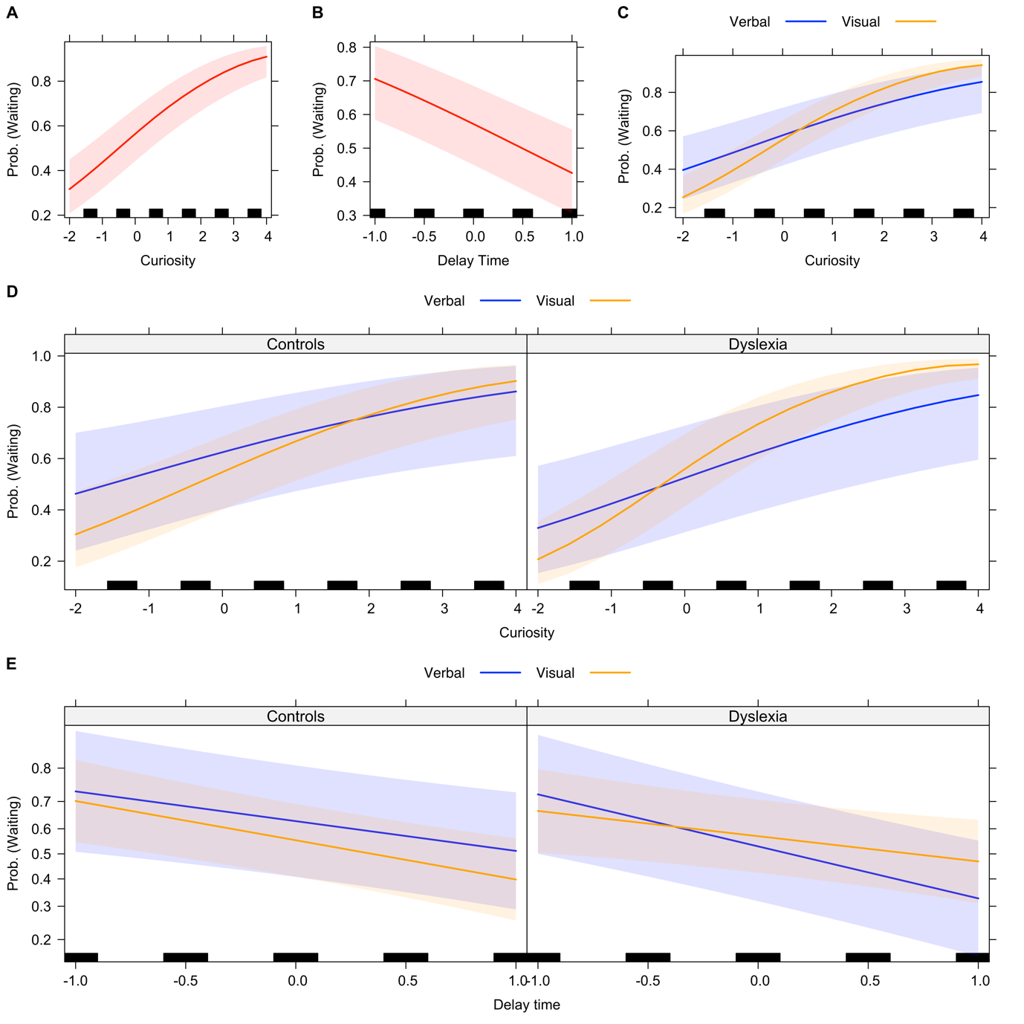

Figure 2. Participants were more likely to wait for an answer when A. they expressed greater curiosity, or B. they encountered a longer delay time. C. All participants were more likely to wait when they were curious about visual information (illustrated in orange, this relationship was attenuated for verbal information (illustrated in blue). D. Relative to controls, participants with dyslexia were more likely to wait for visual information they were curious about (illustrated in orange). Both groups showed a similar relationship between curiosity and waiting times in the case of verbal information (illustrated in blue). E. Participants with dyslexia were less likely to wait for verbal information (illustrated in blue) that was associated with longer wait times, relative to visual information (illustrated in orange). In all plots, solid lines indicate the influence of the factor on the probability of deciding to make a “wait” decision. Lines are scaled by response. The bands around the solid lines indicate the 95% confidence interval. The black lines on the x-axis visually indicate the number of observations at each level of the factor.

Curiosity, information prediction error, and memory

Using the model fitting process outlined above, the best fitting model for likelihood of remembering an item was:

Memory ~ IPE*Group + Curiosity*StimulusType + (1 | item) + (1+ StimulusType | ID)

Participant memory was influenced by group (β = -0.77, SE = 0.29, z = -2.67, p=.008), curiosity (β = 0.25, SE = 0.06, z = 4.41, p<.001), and IPE (β = 0.33, SE = 0.05, z = 7.14, p<.001), see Figures 3A-C (see Supplementary Table 2 for the full model). Across both stimulus types, adults with dyslexia remembered fewer items than controls. A reduced model where the main effect of group was removed while preserving all lower-order interactions was a poorer fit to the data than the full model, χ2(1)=6.93, p =0.008. People were also more likely to remember items for which they expressed greater curiosity. A reduced model (where the main effect of curiosity was removed while preserving lower-order interactions) was a much poorer fit to the data than the full model, p<.001. In addition, people were more likely to remember items when information prediction error was more positive, i.e., when satisfaction was greater than curiosity. A reduced model without the main effect of IPE also offered a poorer fit to the data, p<0.001.

The likelihood of remembering an item was also influenced by an interaction between stimulus type and curiosity (β = 0.17, SE = 0.06, z = 2.63, p=.008). A reduced model without this interaction was a poorer fit to the data, χ2(1)=6.74, p=.009. When examining the effect of curiosity in each stimulus type independently, we found that although curiosity was a significant predictor of memory for both stimulus types, the relationship between curiosity and memory was stronger in the case of the visual stimuli, see Figure 3D.

Finally, we observed that the likelihood of remembering an item was also influenced by an interaction between group and IPE, (β = 0.14, SE = 0.05, z = 2.67, p=0.007). A reduced model without this interaction was a poorer fit to the data, χ2(1)=6.998, p =0.008. We found that both groups showed significant main effects of IPE but this relationship was attenuated in those with dyslexia, see Figure 3E. In other words, those with dyslexia showed a reduced effect of IPE on memory.

As before, we assessed if sentence verification scores might modulate this pattern of effects, by adding these scores as a fixed effect in our best fitting model. The expanded model with these scores did not offer a substantially better fit to the data, χ2(1)=.575, p =0.45.

Given that IPE was the difference between satisfaction and curiosity, we sought to confirm the effect of these two factors on memory independently. We built a model where we included curiosity and satisfaction, in addition to group and type. The results were broadly consistent with the model described above. In brief, we observed a significant main effect of group and satisfaction, an interaction between type and curiosity, an interaction between group and curiosity, and a trend for an interaction between group and satisfaction (see Supplementary Table 3 for full model results). This model did not offer a better fit to the data relative to the model using IPE, p=.22. Given that the model with IPE removed the potential effect of curiosity on satisfaction, we chose to use the model with IPE. Taken together, these results suggest that curiosity and satisfaction influence memory, and that this relationship is different in adults with dyslexia.

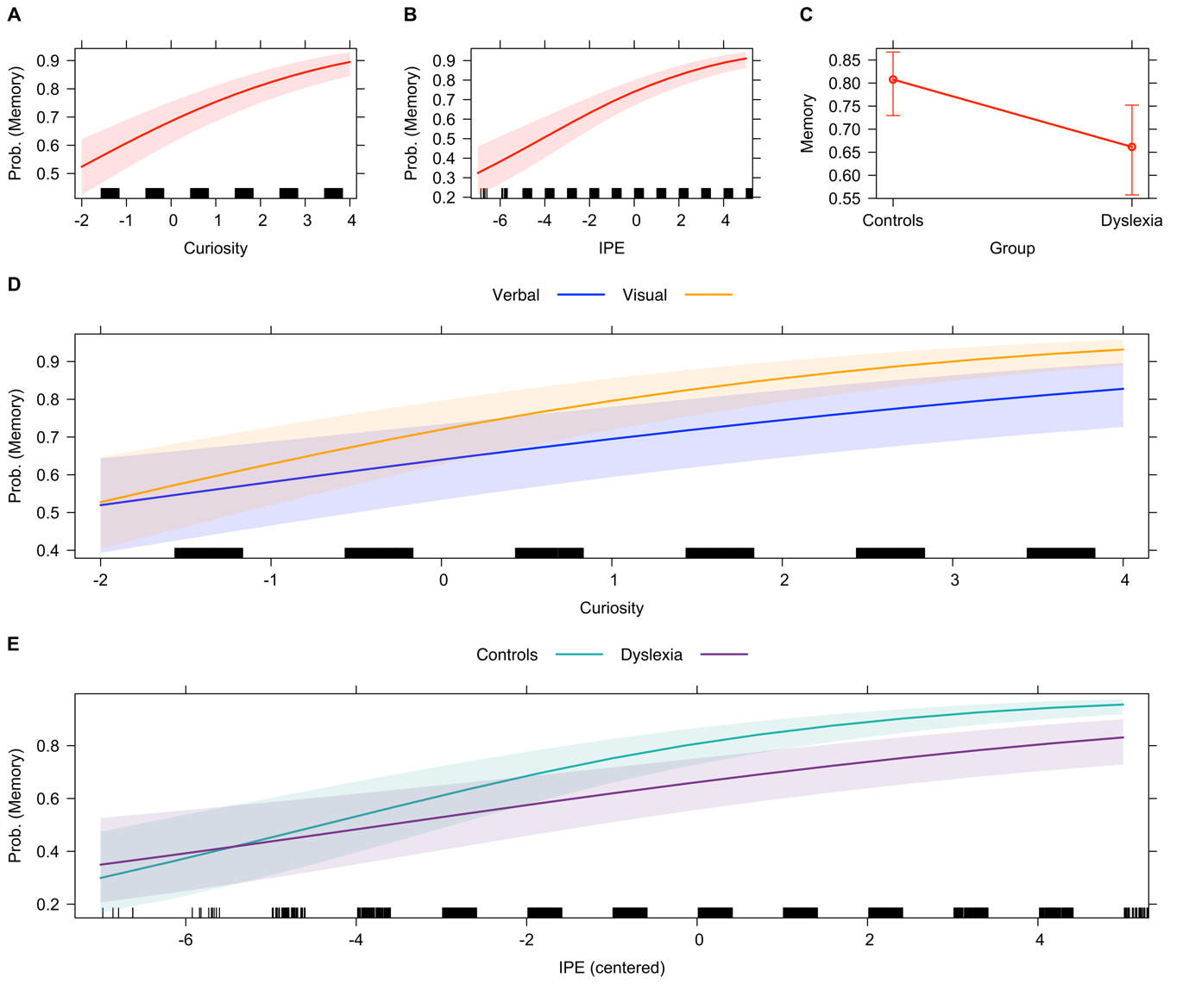
Figure 3. Participants were more likely to remember information when they A) expressed greater curiosity, or B) had positive information prediction errors or IPEs. C) Participants with dyslexia were less likely to remember items than controls. D) The relationship between curiosity and memory was stronger for visual items (illustrated in orange), relative to verbal items (illustrated in blue). This relationship is plotted pooling over those with dyslexia and those without, as the three-way interaction was not significant. E) Adults without dyslexia were more likely to remember information when they had a positive information prediction error, that is, when they found the answer more satisfying than their rated curiosity. Adults with dyslexia showed a significant but weaker relationship between IPE and memory. In all plots, solid thick lines indicate the influence of the factor on the probability of remembering items. The coloured bands around the solid lines, or the error bars in plot C, indicate the 95% confidence interval. The black lines on the x-axis indicate the number of items per level of the factor.

Discussion

In this study, we examined whether adults with dyslexia would show the same effect of curiosity on waiting times, and curiosity-driven memory enhancements, as neurotypical adults. We additionally examined how stimulus type (visual/ verbal) might affect our conclusions. We used a willingness-to-wait task to assess if participants found information rewarding, and were willing to spend time waiting for these pieces of information. We found that participants were more likely to wait for information when they were curious. We observed that the relationship between curiosity and likelihood of waiting was stronger in the case of visual stimuli. In addition, we found that for visual stimuli alone, the relationship between curiosity and likelihood of waiting was stronger in those with dyslexia relative to controls. Finally, our results from the willingness-to-wait task suggested that those with dyslexia were less likely to wait longer intervals for verbal stimuli, suggesting that they placed lower intrinsic value on these items. When investigating memory for items presented, we observed that adults with dyslexia had poorer memory than adults without dyslexia. However, in line with the literature on curiosity and memory, we found that participants with and without dyslexia were more likely to remember information they expressed greater curiosity about. In addition, we observed that type of stimuli modulated the effect of curiosity on memory. Curiosity had a stronger influence on memory for visual items, relative to verbal items. Finally, we found that information prediction errors (IPE), which index the disparity between anticipated value of information and judgement of the information received, were positively predictive of memory. Interestingly, this relationship between IPE and memory and was stronger in controls than in adults with dyslexia.

Broadly speaking, our results are entirely consistent with previous research on curiosity. For instance, we replicate effects of curiosity on the likelihood of waiting for information(Kang et al., 2009; Marvin & Shohamy, 2016; van Lieshout et al., 2018, 2019), and on memory (Fandakova & Gruber, 2020; Jepma et al., 2012; Kang et al., 2009; Marvin & Shohamy, 2016). We used varying wait times and presented it to participants as a positive control, and indeed, we did find that longer wait times were associated with a reduced likelihood of waiting (Marvin & Shohamy, 2016; Roberts et al., 2020). Finally, we replicated findings suggesting that satisfaction, or specifically the discrepancy between the anticipated value of expected information and judgement of information received, modulates memory beyond curiosity (Fandakova & Gruber, 2020; Marvin & Shohamy, 2016; McGillivray et al., 2015). Taken together, this increasingly points to need to understand intrinsic motivation and active sampling, moving beyond participant responses to externally imposed stimuli and thinking about how states of curiosity influence learning (Gottlieb & Oudeyer, 2018; Gross et al., 2020; Kidd & Hayden, 2015). Below, we highlight the effects of stimulus type and group, which we focused on in this experiment.

Stimulus type modulates the relationship between curiosity and the likelihood of waiting for information
Previous studies have used trivia questions to examine the relationship between curiosity, reward, and memory. Here, we built on these studies by building two different sets of stimuli, specifically, questions that were visual in nature (similar to trivia questions in previous studies, but drawing on some visual knowledge), and questions that involved verbal knowledge (learning the meaning of unusual words). We found that for both types of stimuli, increased curiosity was associated with a greater likelihood of waiting for information, suggesting both verbal and visual information was perceived as rewarding. For the visual stimuli, this finding was entirely consistent with the existing literature using trivia questions (Fastrich et al., 2018; Kang et al., 2009; Marvin & Shohamy, 2016). However, is worth emphasising that our visual questions were quite diverse, tapping quite distinct themes. Additionally, although all questions required an association, in some cases this was more abstract such as the association between a country and its flag, and in other cases a unique visual image was shown and then participants were asked to label it. Given this, it is useful to see that the relationship between curiosity and waiting was replicated for these stimuli. It would be interesting to parse this further, and assess if specific types of visual stimuli would be associated with different likelihood functions.

In this vein, our findings using verbal stimuli extend the literature somewhat beyond the typically-used trivia questions, suggesting that participants showed curiosity for learning the meaning of novel words. Ripollés and colleagues have previously shown that extracting the meaning of words from context during reading is intrinsically rewarding, associated with greater subjective ratings of pleasure, brain activity in reward-related regions, and with memory gains associated with reward (Bains et al., 2020; Ripollés et al., 2014, 2016). Our findings add to this line of research, and show that participants are willing to spend time waiting for the meaning of words when they are curious. This further reinforces the idea that learning word meaning is rewarding.

Our stimuli were designed to tap epistemic curiosity, rather than perceptual curiosity. However, perceptual would be an interesting domain to explore further. Perceptual curiosity is typically aroused by novel, strange, or ambiguous stimuli. For instance, Jepma and colleagues (2012) used a task where participants were shown blurred pictures, these pictures were revealed, and participants had to later remember these pictures. Participants’ curiosity was relieved when the ambiguity was resolved, and this was associated with increased activity in reward-processing areas in the brain, as well as improved incidental memory for items. In future studies contrasting perceptually challenging visual and auditory stimuli would be interesting to carry out with these groups.

Stimulus type modulates the effect of curiosity on the likelihood of remembering information
In our assay of long-term memory, we also found a influence of the type of stimuli on the relationship between curiosity and memory. The likelihood of remembering visual stimuli was more strongly associated with curiosity than for verbal memory. This influence of curiosity of memory for our visual stimuli is consistent with previous work that has used trivia-based questions (Fastrich et al., 2018; Gruber et al., 2014, 2014; Marvin & Shohamy, 2016). However, for verbal stimuli, the effect of curiosity on memory was reduced. Our results examining information prediction error shed some light on this, as IPEs were also strongly predictive of participant’s likelihood of remembering items correctly. Although we did try to ensure that prior knowledge of the words we used was limited, participants may have had a more elaborate framework within which to incorporate word meaning. For instance, they may have been familiar with word stems, morphological conventions, etc. – and this may have made a partial prediction about word meaning possible. The later confirmation (or rejection) of this prediction may have led to a stronger discrepancy between expected and received information, which in turn had a strong effect on memory (also see Murayama et al., 2019). In our opinion, this points to the need to use different kinds of stimuli to fully assess the influence of curiosity on memory and learning. Our findings indicate that the relationship between states of curiosity and memory are influenced by the nature of the stimuli, even when both have epistemic value.

The role of curiosity in decision to wait and memory in adults with dyslexia
We primarily designed this study to examine if those with dyslexia would show diminished curiosity, particularly for verbal stimuli. To a large extent, our results indicate that states of curiosity influence those with dyslexia similarly to controls. Those with and without dyslexia found both visual and verbal information rewarding, and were willing to spend time waiting for this information. In fact, adults with dyslexia showed a stronger effect of curiosity on their waiting preferences for visual stimuli, suggesting that visual stimuli may be more intrinsically rewarding in this group. As suggested above, this may either be driven by the more diverse nature of the visual stimuli, or because of the reduced verbal demands – further studies are needed to disentangle these factors. But crucially, these findings indicate that a history of reading difficulty does not diminish the relationship between curiosity for verbal information and likelihood of waiting for it (at least for the simple definitions used within this task). This is particularly interesting as one assumption would be that those with dyslexia would be more uncertain about verbal information, so even when they were curious, the threshold for when they choose to wait would be altered. However, the data does not support this argument.

There is some indication that those with dyslexia are less likely to wait for verbal information when longer waiting times are used. This perhaps suggests that there is less intrinsic value to verbal information, but curiosity might mediate this relationship. These results speak to the value in empirically examining intrinsic motivation in dyslexia, and other populations (also see Gottlieb & Oudeyer, 2018). They have important educational implications, suggesting that eliciting curiosity in those with dyslexia could be a powerful strategy for enhancing their learning. This is especially as our findings show participants with dyslexia appear to receive similar curiosity-driven memory benefits during learning.

Adults with dyslexia show diminished effects of IPE on memory
When examining the disparity between anticipated reward and received reward, and how this disparity predicted future memory, we found that those with dyslexia received a smaller boost than controls. Those with dyslexia may be less sensitive to a change in outcome value in the context of reward-based learning, which may in turn lead to reduced memory benefits. Specifically, diminished cue-outcome evaluation, or reduced incongruity between the prediction and outcome, may make those with dyslexia less likely to remember information that they perceived as interesting or controls. Alternately, individuals with dyslexia may have been less likely to generate a detailed prediction about the received information when an item was presented, which again might lead to a smaller effect of prediction error on memory. Again, future work is necessary to disentangle these possibilities. One way of doing so is to explicitly make individuals generate a prediction, and assess whether these differences are ameliorated. Another approach may be to use neuroimaging methods to study the key regions implicated in epistemic curiosity in dyslexia (Gruber et al., 2014; Kang et al., 2009; Lau et al., 2020; Valji et al., 2019), focusing particularly on structural and functional connectivity in the mesolimbic dopaminergic circuit and the hippocampus.

These results suggests that IPE warrants further investigation in dyslexia, as it has consequences for future behaviour. Murayama and colleagues (2019) have argued a rewarding experience updates the expected value of future new information, which can influence information-seeking behaviour in the future, setting up a positive feedback loop. A similar prediction is set out by the PACE model (Gruber & Ranganath, 2019). There is also some empirical evidence suggesting that information seeking is enhanced when received knowledge is inconsistent with our expectations (Vogl et al., 2020). Indeed, these may be particularly important in development. Novelty or surprise of events are known to provoke explanation-seeking in children, and these behaviours are thought to be powerful drivers of learning (Liquin & Lombrozo, 2020).

Limitations
This study has several limitations. First, we were not able to conduct a power analysis to determine sample size given our use of mixed effects models and the lack of availability of suitable data to simulate when we started. Consequently, the sample size we used is relatively small, and these results therefore do require replication in a larger sample. Second, in this task, we asked people to provide curiosity ratings after they had completed the willingness-to-wait task, similar to the process followed by Marvin and Shohamy (2016). In other studies, such as those by Kang et al. (2009), these ratings were obtained before participants completed the willingness-to-wait task. The similarity of our findings to these other papers does suggest that the ordering of tasks does not have a large effect, however, one way to empirically test this would be to counterbalance task order across participants. Third, our distinction between visual and verbal stimuli is quite broad. Future studies could disentangle this relationship in greater detail, probing the presence of familiar/ unfamiliar phonological items in the case of verbal items, or distinctions between perceptual and epistemic curiosity in the case of the visual items. Finally, we did not ask participants to provide an initial guess when presented with a question. This means we cannot assess the relationship between satisfaction and existing knowledge, i.e., we do not know if an answer where participants made an incorrect guess would be associated with greater or lesser satisfaction. Previous studies have suggested that surprise, associated with receiving the correct answer after providing an incorrect one, modulates brain activity, and could be distinct from satisfaction (Kang et al., 2009). However, other researchers suggest that satisfaction ratings typically employed to calculate information prediction error do index surprise, setting a positive feedback loop into place (Murayama et al., 2019). The relationship between surprise and satisfaction is likely to be modulated by both individual personality traits, participant’s confidence about an answer, as well as situational variables. In future studies, allowing participants to have a guess before the answer is revealed, and rate their confidence about their guess, might help disentangle these related issues.

Summary and conclusions
Our study shows that curiosity appears undiminished in those with dyslexia, including for challenging verbal material. This strongly indicates that adults with and without dyslexia find visual and verbal information rewarding, and this is the first demonstration of this effect in those with dyslexia. Consistent with the available literature on curiosity and memory, our findings also indicate a close relationship between states of high curiosity and enhanced memory. This indicates that stimulating curiosity in individuals with and without dyslexia could have beneficial effects on memory, a finding which could be very important for classroom practice. Additionally, the relationship between IPEs and memory was attenuated in those with dyslexia. These findings strongly point to a need to look at the link between information seeking and memory in dyslexia. These exciting new avenues may point to ways to design better intervention tools for those with dyslexia. They also suggest that curiosity and curiosity-driven memory are important avenues for exploration in other neurodevelopmental disorders, where information seeking may be altered in different ways.

Data availability

Anonymised study data and analysis code is openly available on the Open Science Framework (https://osf.io/j6fp4/). Experimental protocols, such as the willingness-to-wait task and the sentence verification task, can be sampled on Gorilla Open Materials (https://app.gorilla.sc/openmaterials/237000).

References

Alt, M., Hogan, T., Green, S., Gray, S., Cabbage, K., & Cowan, N. (2017). Word Learning Deficits in Children With Dyslexia. Journal of Speech, Language, and Hearing Research, 60(4), 1012–1028. https://doi.org/10.1044/2016_JSLHR-L-16-0036
Anwyl-Irvine, A. L., Massonnié, J., Flitton, A., Kirkham, N., & Evershed, J. K. (2020). Gorilla in our midst: An online behavioral experiment builder. Behavior Research Methods, 52(1), 388–407. https://doi.org/10.3758/s13428-019-01237-x
Bains, A., Barber, A., Nell, T., Ripollés, P., & Krishnan, S. (2020). Stage 1 Registered Report: The role of intrinsic reward in adolescent word learning. Developmental Science. https://doi.org/10.17605/OSF.IO/HKN54
Bates, D., Mächler, M., Bolker, B., & Walker, S. (2014). Fitting Linear Mixed-Effects Models using lme4. ArXiv:1406.5823 [Stat]. http://arxiv.org/abs/1406.5823
Brod, G., & Breitwieser, J. (2019). Lighting the wick in the candle of learning: Generating a prediction stimulates curiosity. Npj Science of Learning, 4(1), 1–7. https://doi.org/10.1038/s41539-019-0056-y
Bromberg-Martin, E. S., & Hikosaka, O. (2009). Midbrain dopamine neurons signal preference for advance information about upcoming rewards. Neuron, 63(1), 119–126. https://doi.org/10.1016/j.neuron.2009.06.009
Bromberg-Martin, E. S., & Monosov, I. E. (2020). Neural circuitry of information seeking. Current Opinion in Behavioral Sciences, 35, 62–70. https://doi.org/10.1016/j.cobeha.2020.07.006
Charpentier, C. J., Bromberg-Martin, E. S., & Sharot, T. (2018). Valuation of knowledge and ignorance in mesolimbic reward circuitry. Proceedings of the National Academy of Sciences, 115(31), E7255–E7264. https://doi.org/10.1073/pnas.1800547115
Clayton, F. J., Sears, C., Davis, A., & Hulme, C. (2018). Verbal task demands are key in explaining the relationship between paired-associate learning and reading ability. Journal of Experimental Child Psychology, 171, 46–54. https://doi.org/10.1016/j.jecp.2018.01.004
Fandakova, Y., & Gruber, M. J. (2020). States of curiosity and interest enhance memory differently in adolescents and in children. Developmental Science. https://doi.org/10.1111/desc.13005
Fastrich, G. M., Kerr, T., Castel, A. D., & Murayama, K. (2018). The role of interest in memory for trivia questions: An investigation with a large-scale database. Motivation Science, 4(3), 227–250. https://doi.org/10.1037/mot0000087
Feng, L., Hancock, R., Watson, C., Bogley, R., Miller, Z., Luisa, G. T. M., Briggs-Gowan, M., & Hoeft, F. (2020). Development of an Abbreviated Adult Reading History Questionnaire (ARHQ-Brief) Using a Machine Learning Approach. PsyArXiv. https://doi.org/10.31234/osf.io/8u5fe
FitzGibbon, L., Lau, J. K. L., & Murayama, K. (2020). The seductive lure of curiosity: Information as a motivationally salient reward. Current Opinion in Behavioral Sciences, 35, 21–27. https://doi.org/10.1016/j.cobeha.2020.05.014
Fox, J., & Hong, J. (2009). Effect Displays in R for Multinomial and Proportional-Odds Logit Models: Extensions to the effects Package. Journal of Statistical Software, 32(1), 1–24. https://doi.org/10.18637/jss.v032.i01
Gottlieb, J., & Oudeyer, P.-Y. (2018). Towards a neuroscience of active sampling and curiosity. Nature Reviews Neuroscience, 19(12), 758–770. https://doi.org/10.1038/s41583-018-0078-0
Gross, M. E., Zedelius, C. M., & Schooler, J. W. (2020). Cultivating an understanding of curiosity as a seed for creativity. Current Opinion in Behavioral Sciences, 35, 77–82. https://doi.org/10.1016/j.cobeha.2020.07.015
Grossnickle, E. M. (2016). Disentangling Curiosity: Dimensionality, Definitions, and Distinctions from Interest in Educational Contexts. Educational Psychology Review, 28(1), 23–60. https://doi.org/10.1007/s10648-014-9294-y
Gruber, M. J., Gelman, B. D., & Ranganath, C. (2014). States of Curiosity Modulate Hippocampus-Dependent Learning via the Dopaminergic Circuit. Neuron, 84(2), 486–496. https://doi.org/10.1016/j.neuron.2014.08.060
Gruber, M. J., & Ranganath, C. (2019). How Curiosity Enhances Hippocampus-Dependent Memory: The Prediction, Appraisal, Curiosity, and Exploration (PACE) Framework. Trends in Cognitive Sciences, 23(12), 1014–1025. https://doi.org/10.1016/j.tics.2019.10.003
Halamish, V., Madmon, I., & Moed, A. (2019). Motivation to learn: The long-term mnemonic benefit of curiosity in intentional learning. Experimental Psychology, 66(5), 319–330. https://doi.org/10.1027/1618-3169/a000455
James, E., Gaskell, M. G., & Henderson, L. M. (2020). Sleep-dependent consolidation in children with comprehension and vocabulary weaknesses: It’ll be alright on the night? Journal of Child Psychology and Psychiatry, n/a(n/a). https://doi.org/10.1111/jcpp.13253
Jepma, M., Verdonschot, R. G., van Steenbergen, H., Rombouts, S. A. R., & Nieuwenhuis, S. (2012). Neural mechanisms underlying the induction and relief of perceptual curiosity. Frontiers in Behavioral Neuroscience, 6. https://doi.org/10.3389/fnbeh.2012.00005
Kang, M. J., Hsu, M., Krajbich, I. M., Loewenstein, G., McClure, S. M., Wang, J. T., & Camerer, C. F. (2009). The Wick in the Candle of Learning: Epistemic Curiosity Activates Reward Circuitry and Enhances Memory. Psychological Science, 20(8), 963–973. https://doi.org/10.1111/j.1467-9280.2009.02402.x
Kidd, C., & Hayden, B. Y. (2015). The Psychology and Neuroscience of Curiosity. Neuron, 88(3), 449–460. https://doi.org/10.1016/j.neuron.2015.09.010
Lau, J. K. L., Ozono, H., Kuratomi, K., Komiya, A., & Murayama, K. (2020). Shared striatal activity in decisions to satisfy curiosity and hunger at the risk of electric shocks. Nature Human Behaviour, 4(5), 531–543. https://doi.org/10.1038/s41562-020-0848-3
Liquin, E. G., & Lombrozo, T. (2020). Explanation-seeking curiosity in childhood. Current Opinion in Behavioral Sciences, 35, 14–20. https://doi.org/10.1016/j.cobeha.2020.05.012
Litt, R. A., & Nation, K. (2014). The nature and specificity of paired associate learning deficits in children with dyslexia. Journal of Memory and Language, 71(1), 71–88. https://doi.org/10.1016/j.jml.2013.10.005
Marvin, C. B., & Shohamy, D. (2016). Curiosity and reward: Valence predicts choice and information prediction errors enhance learning. Journal of Experimental Psychology: General, 145(3), 266–272. https://doi.org/10.1037/xge0000140
McGeown, S. P., Norgate, R., & Warhurst, A. (2012). Exploring intrinsic and extrinsic reading motivation among very good and very poor readers. Educational Research, 54(3), 309–322. https://doi.org/10.1080/00131881.2012.710089
McGillivray, S., Murayama, K., & Castel, A. D. (2015). Thirst for knowledge: The effects of curiosity and interest on memory in younger and older adults. Psychology and Aging, 30(4), 835–841. https://doi.org/10.1037/a0039801
Murayama, K., FitzGibbon, L., & Sakaki, M. (2019). Process Account of Curiosity and Interest: A Reward-Learning Perspective. Educational Psychology Review, 31(4), 875–895. https://doi.org/10.1007/s10648-019-09499-9
R Core Team. (2020). R: A language and environment for statistical computing. R Foundation for Statistical Computing. https://www.R-project.org/.
Reio, T. G., & Wiswell, A. (2000). Field investigation of the relationship among adult curiosity, workplace learning, and job performance. Human Resource Development Quarterly, 11(1), 5–30. https://doi.org/10.1002/1532-1096(200021)11:1<5::AID-HRDQ2>3.0.CO;2-A
Ripollés, P., Marco-Pallarés, J., Alicart, H., Tempelmann, C., Rodríguez-Fornells, A., & Noesselt, T. (2016). Intrinsic monitoring of learning success facilitates memory encoding via the activation of the SN/VTA-Hippocampal loop. ELife, 5, e17441. https://doi.org/10.7554/eLife.17441
Ripollés, P., Marco-Pallarés, J., Hielscher, U., Mestres-Missé, A., Tempelmann, C., Heinze, H.-J., Rodríguez-Fornells, A., & Noesselt, T. (2014). The Role of Reward in Word Learning and Its Implications for Language Acquisition. Current Biology, 24(21), 2606–2611. https://doi.org/10.1016/j.cub.2014.09.044
Roberts, A. R., Shaddy, F., & Fishbach, A. (2020). Love is patient: People are more willing to wait for things they like. Journal of Experimental Psychology: General, No Pagination Specified-No Pagination Specified. https://doi.org/10.1037/xge0000999
Snowling, M. J., Muter, V., & Carroll, J. (2007). Children at family risk of dyslexia: A follow-up in early adolescence. Journal of Child Psychology and Psychiatry, 48(6), 609–618. https://doi.org/10.1111/j.1469-7610.2006.01725.x
Stahl, A. E., & Feigenson, L. (2015). Observing the unexpected enhances infants’ learning and exploration. Science, 348(6230), 91–94. https://doi.org/10.1126/science.aaa3799
Subbotsky, E. (2010). Curiosity and exploratory behaviour towards possible and impossible events in children and adults. British Journal of Psychology, 101(3), 481–501. https://doi.org/10.1348/000712609X470590
Valji, A., Priemysheva, A., Hodgetts, C. J., Costigan, A. G., Parker, G. D., Graham, K. S., Lawrence, A. D., & Gruber, M. J. (2019). Curious connections: White matter pathways supporting individual differences in epistemic and perceptual curiosity. BioRxiv, 642165. https://doi.org/10.1101/642165
van Bergen, E., Snowling, M. J., Zeeuw, E. L. de, Beijsterveldt, C. E. M. van, Dolan, C. V., & Boomsma, D. I. (2018). Why do children read more? The influence of reading ability on voluntary reading practices. Journal of Child Psychology and Psychiatry, 59(11), 1205–1214. https://doi.org/10.1111/jcpp.12910
van Lieshout, Traast, I., de Lange, F., & Cools, R. (2019). Curiosity or savouring? Information seeking is modulated by both uncertainty and valence. [Preprint]. PsyArXiv. https://doi.org/10.31234/osf.io/5y6pz
van Lieshout, Vandenbroucke, A. R. E., Müller, N. C. J., Cools, R., & Lange, F. P. de. (2018). Induction and Relief of Curiosity Elicit Parietal and Frontal Activity. Journal of Neuroscience, 38(10), 2579–2588. https://doi.org/10.1523/JNEUROSCI.2816-17.2018
Vogl, E., Pekrun, R., Murayama, K., & Loderer, K. (2020). Surprised–curious–confused: Epistemic emotions and knowledge exploration. Emotion, 20(4), 625–641. https://doi.org/10.1037/emo0000578
von Stumm, S., Hell, B., & Chamorro-Premuzic, T. (2011). The Hungry Mind: Intellectual Curiosity Is the Third Pillar of Academic Performance. Perspectives on Psychological Science, 6(6), 574–588. https://doi.org/10.1177/1745691611421204
Wagner, R. K., Zirps, F. A., Edwards, A. A., Wood, S. G., Joyner, R. E., Becker, B. J., Liu, G., & Beal, B. (2020). The Prevalence of Dyslexia: A New Approach to Its Estimation. Journal of Learning Disabilities, 53(5), 354–365. https://doi.org/10.1177/0022219420920377

