Technological Forecasting at the

Stock Market

THEODORE MODIS

ABSTRACT

Under the assumption that competition (Darwinian in nature) reigns in the stock market, we analyze the behavior of company stocks as if they were species competing for investors’ resources. The approach requires the study of dollar values and share volumes, daily exchanged in the stock market, via logistic growth functions. These two variables, in contrast to prices, obey the law of natural growth in competition, which like every natural law, is endowed with predictability. A number of unexpected insights about the stock market emerge. The forecasts indicate that whereas there is no looming crash in the near future, no significant growth should be expected either. The DJIA is to hover around 9500 depicting large erratic excursions above and below this level for a few years. The use of Volterra-Lotka equations demonstrates that the 1987 crash altered the stock-bond interaction from a symbiotic to a predator-prey relationship with stocks acting as predators. This research work has lead to the publication of the book An S-Shaped Trail to Wall Street by T. Modis, (Growth Dynamics, Geneva, 1999).

Introduction
Every now and then proponents of the exact sciences bring their trade to the stock market. In the 1980s we saw the so-called rocket scientists (for example, The Prediction Company), and chaos scientists (such as, Benoit Mandelbrot) try their hand, but no one broke the bank. As the shine of chaos and fractals wore off, complexity came into the limelight, incorporating admixtures from biology and ecology. Complexity looks at a bigger picture by paying attention to the law of competition. However, the object of most studies in the stock market continues to be the squiggly charts of stock prices and market indices, indicators that do not constitute competition variables, because they do not represent limited resources. The fact that the IBM stock goes up does not prevent the AT&T stock from also going up. Competition emerges only when we deal with a limited resource and one competitor’s acquisition entails another competitor’s nonownership.
The work reported here assumes that there are two distinct kinds of competition in the stock market: Stocks compete for investors’ attention, and for investors’ money. Companies try to make their stocks attractive (for example, by giving dividends) to

THEODORE MODIS is the founder of Growth Dynamics, an organization specializing in strategic forecasting and management consulting. http://www.growth-dynamics.com
Address correspondence to Theodore Modis, Growth Dynamics, Rue Beau Site 2, 1203 Geneva, Switzerland. E-mail: tmodis@compuserve.com

attract investors’ attention and their cash, as if they were products in a shop window. But attracting attention and attracting dollars are two different processes because investors and dollars do not precipitate on the same stock at the same rate. A popular low- price stock may attract more investors but less money than a highly priced blue chip stock. The identification of the appropriate competition variables permits the use of the mathematical formulations designed for ecosystems by biologists and ecologist, such as, the logistic function and the Volterra-Lotka system of equations. Originated by Verlhust in mid-19th century, mathematical ecology today boasts sophisticated and complete solutions to the problem of interacting species, to which many cross-discipline
scientists have contributed [1–8]. Here is a chronology of proponents in the field:
Verhulst, P. F.: Recherches mathe´matiques sur la loi d’accroissement de la popula- tion, Nouveaux Me´moires de l’Acade´mie Royale des Sciences et des Belles-Lettres de Bruxelles, 18, 1–40 (1845).
Lotka, Alfred J.: Elements of Physical Biology. William & Wilkins Co., Baltimore, MD, 1925.
Volterra, Vito: Lec¸ons sur la the´orie mathe´matique de la lutte pour la vie. Gauthier- Villars et Cie, Paris, France, 1931.
Leslie, P. H.: A Stochastic Model for Studying the Properties of Certain Biological Systems by Numerical Methods, Biometrika 45, 16–31 (1957).
Pielou, E. C.: An Introduction to Mathematical Ecology, Wiley Interscience, New York, NY, 1969.
Odum, E.: Fundamentals of Ecology, Saunders, London, UK, 1971.
Williamson, M.: The Analysis of Biological Populations, Edward Arnold, London, UK, 1972.
Smitalova, Kristina, and Sujan, Stefan, 1991: A Mathematical Treatment of Dynami- cal Models in Biological Science. Ellis Horwood, West Sussex, England.
The Volterra-Lotka system of equations does not only incorporate the dynamics of competition in the classical sense (natural selection, survival of the fittest, predator-prey interactions, etc.). In a discrete form, these equations model chaotic systems. Chaos scientists have argued that equilibrium and orderly growth are only the tip of the iceberg, whereas the richness of our world comes from the noisy, apparently random behavior encountered in the unpredictable patterns of currency movements and market reactions. They wanted to believe that their theory contained all one needs to know about markets. But chaos studies have proven of small added value in predicting the future. I heard Mandelbrot himself admit in public that having succeeded in mathematically reproducing the chaotic patterns seen in stock-market indices did not bring him any closer to becoming rich.
Modeling the stock market as an ecosystem is an attempt to leverage the combination of a defensible hypothesis with a well-established fact. The hypothesis is that competition dictates what happens in the stock market. The fact is that we know how competition works. The rest is technicalities. As a physics student at Columbia University in the 1970s I was privileged to have several Nobel Prize laureates as teachers. One of them, Polykarp Kusch, used to argue that physics experiments are either trivial or impossible. What he meant was that scientific rigor can make abstraction of technical difficulties but must respect the laws. In that perspective, going to the moon was trivial, as it involved only technicalities, but accelerating an electron to a speed greater than the speed of light is simply impossible. By the same token, modeling the 4,000 odd

stocks traded at the NYSE, as individual interacting species, would in principle be trivial, but the technicalities would involve the determination of some 32 million parameters!
To avoid that problem, the work reported here concentrates on an aggregate level.
The 30 industrials of the Dow Jones Industrial Average (DJIA) are seen as a single organism, behaving as a major long-lived species of the stock market. This approach enjoys an additional advantage. Individual company stocks may undergo a “mutation” following a merger, an acquisition, reorganization of the company, or a simple stock split. Mutations can interfere with the continuity of a stock’s competitive role as determined from a historical time series. But the continuous appearance of such mutations among the constituents renders the ensemble rather insensitive. The DJIA rarely undergoes mutations (that is, a redefinition of its composition).
The analysis produces a number of insights and forecasts for the NYSE. The intend behind obtaining these results is not to provide the readers with investment advice but to demonstrate that there may be good reason for taking technological forecasting to the stock exchange.

Setting the Scene
The limited resource that engenders competition is related to the finite size or capacity of the niche hosting the growth. For a rabbit population it is the capacity of their ecological niche; that is, the amount of grass available on the range they inhabit. For a toddler acquiring vocabulary, the niche capacity is the total number of words he or she is exposed to at home; that is, the vocabulary used by the care givers. The niche capacity is the ceiling toward which the population of rabbits (or words acquired) will grow following an S-shaped pattern. This ceiling serves as a target for the growing population. It shows where the population aims to be at the end of the growth process, and it should not vary over time.
However, there are competitive growth processes in which the niche is also increasing as the population increases. The introduction of some products may cause the market niche to expand. Tools have a tendency to increase their niche; for example, a knife may be used as a screwdriver or a prying instrument. Computers continue to satisfy more and more needs. If the niche capacity increases with time, growth is not capped. Does this mean there can be growth with no competition? No, competition is simply hidden in these cases, and one must be clever in order to detect it and discern winners and losers.
In the long run, there can be no growth without competition. Growth’s multiplication mechanism (be it for rabbits or products) says that each birth will give rise to more births. Populations grow exponentially in the beginning. Unless the niche capacity grows at the same exponential rate, there will be congestion that will trigger competition, and result in a survival-of-the-fittest selection. Because no niche can grow exponentially forever, there will always be competition to limit the growth, sooner or later. But one can still discern winners and losers from the very beginning by looking at market shares. The niche capacity may grow with time, but some competitors will grow faster than others. They will be the winners and the ones growing more slowly the losers. In the market-share picture the losers will have a declining trajectory even if they may be growing in absolute numbers. This was the case in the competitive substitution of cars for horses in the beginning of the 20th century. The numbers of horses was not only greater than the number of cars but it kept increasing until the early 1920s. However, during the same period the number of cars increased at a much faster rate. That is why in the relative picture, depicting shares of the overall personal “vehicle” market, the horses were on a declining trajectory from the turn of the century [9].
Looking at market shares has another advantage. It brings out competitive advantages of a “genetic” nature, producing evidence for a Darwinian character of the competition. It avoids overall disturbances, common to all competitors, such as crises, wars, and stock market crashes. In a stock market crash all stocks go down at the same time and it is difficult to tell winners from losers by looking at the absolute numbers. In the case of substitution of cars for horses the evolution of the market-share trajectories did not deviate from the smooth natural S-shaped courses even during the mid 1910s when a world war took place “quietly” in the background.
This work brings the mathematical formulations of ecological systems to the stock market, maintaining that investment instruments compete like species. It uses the notions of niche, market share, and interactions among species to understand the behavior of individual company stocks, the 30 DJIA industrials as a whole, and in more detail stocks versus bonds.
As with other industrial applications of biological models, one encounters fundamental differences between nature and the stock market. For example, in nature the competitive roles (predator, prey, parasite, etc.) are genetically predetermined and impossible to change. But in the world of business, companies can take action (such as, mergers, acquisitions, company spin-offs, and restructuring) to alter these roles. The reader can find a complete discussion of such “genetic” re-engineering of corporations in a previous publication in this Journal [10].
Changes in the competitive roles will interfere with this analysis because logistic growth for a species population is valid only as long as the species does not change character. Mutations create new species that follow different curves. As a consequence, a stream of cascading logistics will better describe a frequently mutating company than can a single logistic curve.
Another difficulty is the definition of a market niche. For example, do the three computer manufacturers IBM, Compaq, and Hewlett-Packard together constitute a market niche? Can we group them together and look at them as a closed system, or should we look at them as only three out of many members of the bigger computer market? Evidence arguing for the existence of such a microniche would be that the envelope representing the sum of the three populations traces a logistic pattern over time. Other evidence may be to know independently that these three are the only computer manufacturers that offer products in a certain geographical area. In this case, the geographical area constitutes a market niche, and the evolution of the three market shares becomes describable (and predictable) by the Volterra-Lotka equations for three species occupying and interacting in the same ecological niche.
For this work all stocks in the NYSE are classified into three types of species. One species is the NYSE taken as a whole. Despite links and interactions with other stock exchanges around the world, it seems a safe assumption to consider the NYSE as a niche by itself. It has its own rules, traditions, and culture. It represents over 80% of all stock exchange transactions in the United States, and is the most important stock exchange in the world. Another species is the Dow Jones itself. The 30 industrial stocks used in the calculation of the DJIA form a microcosm within the NYSE. They all are leading blue chips, household names, and share a common identity, often posing as a single alternative to prospective investors. It is reasonable to assume that the 30 together behave as a single species. This assumption is confirmed by the fact that the evolution of the DJIA over time is amenable to a single-curve description over extended periods

of time, during which the constituent companies may go through several shorter curves. Finally, each one of the 30 industrials can be studied individually, but the time frame of a single-curve description must then be kept short.
The analysis is largely based on two sets of historical data consisting of end-of-day quotes. Both sets include four time series: the level of DJIA, the share volume exchanged by the 30 industrials, the total NYSE share volume, and the total NYSE dollar volume. One set goes back 10 years and contains daily quotes. The other set goes back 50 years but contains snapshots six months apart, taken at the end of April and again at the end of October, thus defining winter and summer semesters in a special way. The decision to sample history in this way was motivated by the Halloween Indicator, as Michael O’Higgins whimsically calls an interesting observation he made in his book Beating the Dow [11].
  - THE HALLOWEEN INDICATOR REVISITED
O’Higgins argues that 85% of gains with the DJIA (just capital gains, not dividends) occur between October 31 and April 30. He claims to have deduced this observation from data between 1925 and 1989. He points out that several market analysts have established that certain months have historically been significantly better for the market than others for a variety of reasons. His own explanation for the Halloween Indicator is fragmentary and presents a different argument for each month.
After-the-fact explanations are less convincing than what the data themselves say. It is intriguing that both the 1929 and the 1987 crash occurred outside O’Higgins’ fertile winter semester. Furthermore, despite the fact that the 1929 crash signaled the beginning of a many-year decline, the DJIA following the October 1929 crash increased consistently—if modestly—until April 1930.
There is confirmation of O’Higgins’ findings. Over the last 30 years, the DJIA gains during winter semesters turned out to be the only gains. On a compounded annual basis between October 1968 and October 1998, winter semesters were characterized by a 9.1% gain, whereas summers by a 1.0% loss. But the data permitted a search for trends of this winter-summer asymmetry. Figure 1 shows that there is a general trend toward higher gains in both semesters, but that the difference remained unchanged. During the last five years the average gains on a compounded annual basis still differed by 10 percentage points (winter’s 13.3% compared to summer’s 3.7%). It could be that investors have not yet become aware, or simply that they have not yet reacted to this piece of information. Risk-averse strategies could benefit from portfolios employing a six-months-on six-months-off the NYSE strategy.
  - TWO KINDS OF COMPETITION
It is almost redundant to say that there is competition in the stock market. It is less obvious to identify the niche, the competitors, and what they are competing for. You may say there is competition among investors, or that company stocks compete through their price. Such statements contain part of the truth, but they do not constitute rigorous descriptions of what is happening. It is true that companies compete in the marketplace and their success is reflected in the way their stock price moves. As a consequence, the most talked about and the most accessible piece of information about a stock is its price. However, the price does not rate the competitiveness of the players. The fact that IBM’s stock closed at $150 and AT&T’s at $75 one day does not imply that IBM outperformed AT&T by a factor of two on some competitive issue that day. Moreover, the price of a stock is not a limited resource. Price changes for one stock (for example, via stock splits) have no direct impact on the prices of other stocks. To

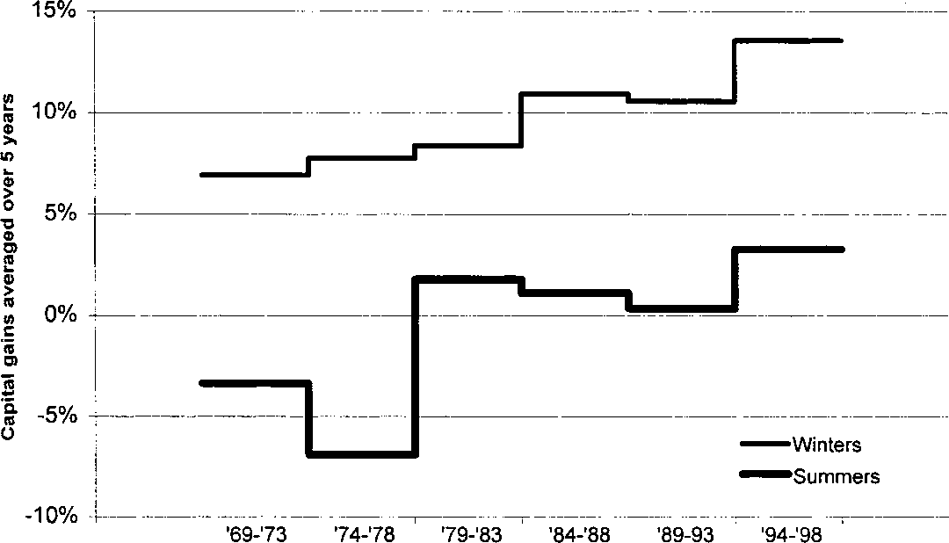

Fig. 1. Winter semesters, as defined in the text, consistently gave higher returns than summer semesters during the last 30 years.

better understand what happens in the stock market let us go back and take a closer look at what happens in the real-business world, the marketplace.
A limited resource breeds competition because one competitor’s acquisition entails another competitor’s nonownership. In the marketplace, expenditure budgets are such a resource. The money spent in acquiring one product is no longer available for acquiring another one. Consequently, company products compete for consumers’ money. But consumers’ needs also constitute a limited resource. Once a need is satisfied, the associated market opportunity disappears. As a result, company products also compete in satisfying consumer needs. Products and services compete in both these dimensions and, to the extent that prices among competitors vary, the nature of the competition for money will be different from the nature of the competition for satisfying the need. Let us highlight this difference with a hypothetical example of a market niche with only two products at different prices.
Let us suppose that the luxury-car market in American consists of only two car manufacturers, Rolls Royce and Lincoln Continental, the former prices at $200,000 and the latter at $60,000. Now imagine the following extreme marketing ploy by Rolls Royce: They offer a Lincoln Continental free with every Rolls sold! In the ensuing competitive struggle there will be a “parasitic” type of relationship in units sales because Lincoln benefits from every Rolls sold, but not vice-versa. But there will be pure competition of the rabbit-rabbit type in dollars sales since a sale of either brand will render a sum of money unavailable for other sales.
Studying competition independently in units and in dollars offers a science-based approach to determine the correct future price for a given product. Competition is predictable because it obeys known natural laws. We can study the evolution of competing species’ populations over a period of time and project their trajectory into the future. We can do this separately for the “population” of dollars and the “population” of units. We can then take the ratio of the two trajectories to predict the natural price of the product in question.
Competition in the stock market is intrinsically the same as in the marketplace. Companies sell shares to capture investors’ money. They can be seen as species engaged in a Darwinian struggle for survival of the fittest. The two competition processes are again for dollars and for units, two variables that constitute limited resources. The units

in this case are a measure of investors’ attention or preoccupation. An increasing volume of shares of a stock reflects an increasing preoccupation of investors by this stock. Attention also behaves like a limited resource. As in personal relationships, if you give your attention to one person, you cannot at the same time give it to some one else.
  - VOCABULARY THAT YIELDS INSIGHTS
Similarities between scientific jargon and everyday vocabulary are not accidental. Science has for centuries supplied definitions that added rigor to common notions. Words such as force, speed, work, impulse, action, energy, harmonic, and potential mean the same thing in science as in everyday life, but in science the definition is precise and rigorous. It is unfortunate that in recent decades physicists (particle physicists in particular) have deviated from this tradition, and began employing arbitrary names such as quarks, strangeness, beauty, and charm, in poor relation to the everyday meaning of these words. In treating the stock market as an ecosystem I will stick to the classical tradition of physicists, and define and use meaningful names for the quantities involved. In so doing we achieve not only clarity of communication but also unexpected insights.

Stock-Market Attention
Sorting the NYSE stocks by their daily share volume rates the stocks according to popularity. This type of sorting is in fact done officially to some extent. The nine most active issues are highlighted daily as an important piece of stock-market news. These stocks become remarkable and newsworthy because of the fact that investors were preoccupied by (gave their attention to) these stocks and not by others during the day. The share volume can be called stock-market attention because it reflects investors’ preoccupation. We will see below that adding up the stock market attention over all stocks gives the total NYSE stock-market attention, which is nothing but the daily total share volume at the NYSE.

Stock-Market Value
Another rating of performance for each stock is the dollar value exchanged. The dollar value for a particular stock is equal to the stock’s price times the number of shares transacted at that price. Let us call this product the stock-market value in analogy to the term market value usually attributed to the product stock price times the number of a company’s outstanding stocks. Despite the similarity in the definitions of market value and stock-market value there is little correlation between them. Market value changes only when the stock price changes, but stock-market value also changes with the volume of transactions. On a given day, the opening and closing price of a stock may end up the same, hence zero change in the company’s market value, and yet the daily stock-market value may be enormous if controversial rumors about that company circulated on the NYSE floor that day and caused large exchange volumes.

Natural Selection
Stock-market value and stock-market attention obey the law of natural selection. Selection occurs at the moment of the transaction. The various stocks exert attraction on investors’ money and on investors’ attention. For the average investor this attraction is proportional to the percentage market share of the NYSE totals. The average investor’s attention is “pulled” by a force proportional to the ratio of stock’s share volume divided by the total NYSE share volume, which is the probability of buying one share of this stock. But the investor’s money is being “pulled” by a force proportional to the ratio of stock dollar value divided by the total NYSE dollar value, which is the probability that one dollar becomes invested in this stock.

The moment you decide to buy one share of a particular stock, you are making a decision not to buy a share of all other stocks. Similarly, when you place one of your dollars on one stock, you are not placing it in all other stocks. Choosing what you think is best at that moment constitutes the selection process. At the end of a given day, you together with all other investors will have fixed these two probabilities for each stock at NYSE, thus rating them for performance that day in the race for investors’ favor.
Every transaction in the stock market is simultaneously a buy and a sell. For the sake of clarity we look at transactions as buys hers. But one could consider transactions simply as exchanges without having to modify the reasoning. Selection would then be manifested through the fact that this stock was being exchanged instead of others. In both cases competitiveness for a stock increases when one or both of the two fractions increases.

Noisy Stocks
Volume is correlated to value but not 100%. It is possible for the volume to increase while the value decreases and vice versa. The average volume among the active issues is always higher than that among the 30 industrials. But as a rule the average price among the active issues is lower than that of the 30 industrials. It turns out that more often than not the average value of the active issues is lower than the average value of the 30 industrials.
A combination a high volume and a low value speaks for a “noisy” stock. It implies many transactions at a low price. “We’ll buy the stock but we will not necessarily put our money there,” say the investors. This is not quite equivalent to “much ado about nothing.” Getting attention increases competitiveness on the stock-market floor. Being among the active issues is a distinction. After all, most active issues are blue-chip stocks, and one third of them typically belongs to the 30 industrials. In the extreme case in which all NYSE attention is devoted to only a handful of stocks, the value of these stocks must also rise. If all brokers and traders became preoccupied with buying and selling a handful of stocks, no matter how small the price of these stocks, their dollar value would increase, if for no other reason, than that investors did not have time to make any other investments that day. But will the stockholders or the companies themselves benefit in real life? Not necessarily, because stock-market value and market value are two different and poorly correlated entities.
Shareholders want the prices to increase, but prices can be high with large volumes as well as with small ones. For the price to go up, the value must increase without the volume increasing. The situation calls for more investors’ money to become tied up in exchanges over this stock. Alternatively, the price also goes up when the volume decreases without the value decreasing. In this case the stock “cools off,” as investors’ attention drifts away, but their money stays on the stock. We will examine more closely the evidence for real-life benefits related to gains in stock market competitiveness in Section 3.

The Attention Factor
Dividing value by volume gives us the stock’s price. Dividing them the other way around gives us the inverse of price, which has an interesting interpretation of its own. The inverse of price is expressed in shares per dollar; it indicates how many shares one can buy for one dollar—most often a small fraction of one. This quantity is interesting because it represents the amount of attention required for one dollar to be invested. Let us call it the attention factor (AF).

AF = 1
Price

On October 31, 1996, the AT&T (T) and General Electric (GE) stocks had very similar dollar values, $0.2 billion each. But the AT&T share volume was three times that of GE (6.2 million vs. 2 million shares). It took three times as many transactions to invest the same amount of money in AT&T stocks as in GE. We say that AT&T’s attention factor was three times that of GE’s for that day.
The concept of the attention factor completes the symmetry in the relationship between volume and value, namely:
value = price × volume
volume = (attention factor) × value
Besides helping us gain insights, these definitions make consistency checks possible, thus adding robustness to the approach (see Section 2.5 on competitiveness below).

Harmony in Action
For a given stock only two of the three variables value, price, and volume, are independent. The two most frequently quoted ones in the daily news are price and volume. They are only partially correlated. A stock’s price may go up while its volume goes down and vice versa. It is also possible that they both go up or down simultaneously. We need to take both pieces of information into account, in order to probe into what is really happening. Price and volume (or stock-market attention) constitute two dimensions which taken together produce a powerful instrument for understanding the behavior of stocks in the future. Like stereoscopic vision that permits one to focus at a certain depth in space, one also needs two different points of view to see clearly at a certain depth in time. Moreover, the fact that their product translates into dollars can be taken as evidence that price and attention constitute conjugate coordinates.
Conjugate coordinates in physics are coordinates whose product produces action, and the sociobiological equivalent of action is money. Typical conjugate coordinates in physics are energy and time, or distance and momentum. Conjugate coordinates also obey Heisenberg’s celebrated uncertainty principle, which postulates that it is impossible to specify an object’s location and momentum with unlimited precision. In mathematics, conjugate relations make it so that the average of the one is the harmonic average of the other. A harmonic average is computed by calculating the average of the inverse of all the entries and then taking the inverse of this average. This is what we will do in Section 2.5 on competitiveness below to calculate the average NYSE attention factor. The above terminology and discussion shed new light on the stock market. The connotations implied here are not of accidental or esoteric origin. Harmony stems from the fundamentality ingrained in conjugate coordinates. As for the notion of action in the stock market, nothing can represent it better than the daily amount of dollar
value exchanged.
  - MARKET SHARES
One archetypical measure of a company’s competitive performance is its market share. If the market share is increasing, the company is most likely enjoying competitive advantages. But often it is not specified to what market share we are referring. When we read that Apple’s market share is 20% of the personal computer (PC) market, it is not always clear whether 20% of all PC buyers buy Apple computers, or whether 20% of all expenditures on PCs go to Apple The difference may be important.

If all products in a market had the same price, market shares in units would be identical to market shares in dollars. But because prices vary, we find ourselves in a world in which there are two kinds of competition: Competition for consumers’ dollars, and competition for consumers’ needs. The performance of the competing companies can be rated via their market share in dollars and their market share in units. The two market shares can be quite different. In the earlier example of the Rolls-Lincoln market niche, the market share in units of Rolls may be 25% while its market share in dollars, due to higher prices, could be 40%. Such a differentiation originates with market shares, but shapes activities in the departments of marketing, advertising, price-setting strategies, and other departments of the competitors’ organizations.
Market shares represent probabilities. They dictate what will happen on the average over large numbers of transactions. It would be mathematically correct to say that when the average oil-rich sheik goes shopping for a luxury car in America, he will write a check 40% of which will be for a quarter of a Rolls Royce, and the remaining 60% for three quarters of a Lincoln Continental. But this may be the situation today. If our sheik comes back next year, the market shares may have changed significantly as a consequence of the fact that competitive advantages vary with time. The evolution of market shares describes the evolution of the competitive struggle. Any difference between the market share in units and the market share in dollars is due to differences in price among the competitors.
Another characteristic of market share is that it constitutes—by definition—a limited resource. One competitor’s gains are necessarily at the expense of one or more of the other competitors. For all these reasons much of the stock-market analysis in this work uses market shares, or more precisely, stock-market shares (no pun intended). For each company stock one can define two variables expressed as percentages. One variable is a percentage of the total daily NYSE share volume, and the other a percentage of the total daily NYSE dollar value. Numerically these percentages are equal to the probability that the average investor buys the stock, and the probability that his or her money becomes invested in the stock, respectively. The market share in units indicates the probability that one share is sold, and the market share in dollars indicates the probability that one dollar is invested in this stock.
With other things being equal, when you call your stockbroker with the intention to invest some money, the probability that you will end up buying a particular stock is not equal to the probability that one of your dollars will be invested in that stock. We are only speaking statistically, of course, which is what is behind the phrase other things being equal. You may argue that when you have made up your mind about an investment, other things are not at all equal, and that all your dollars will end up on the stock you have chosen. This is true, just as it is true for every other investor who makes similar moves. But that is how statistics works. When the 50-odd million American investors place their dollars in the 4,000-odd stocks on the Big Board, you can be sure that the laws of statistics and the laws of natural competition will be honored. These are the laws we are trying to exploit here in order to see more clearly into the future. Among the 4,000 issues listed at NYSE, prices range from a fraction of a dollar to hundreds of dollars. Consequently, attention factors range from several shares per dollar to a fraction of a share per dollar. To calculate the average price and the average attention factor for all shares sold at the NYSE, we need to introduce the appropriate weights. These weights are nothing else but the probabilities mentioned above; that is, the probability of selling a share and the probability of investing a dollar. The next section shows the mathematical definitions and gives evidence for a certain amount of rigor, elegance, and robustness associated with this approach.

  - COMPETITIVENESS
Competitiveness in the stock market can be taken as a proxy for importance and popularity. In other words, the larger a stock’s share volume and the larger its dollar value exchanged, the more important and the more popular the stock will be. But as mentioned earlier, the true competitive advantage is identified better if one looks at market shares.
The price of stock i, let us call it P_{i}, is expressed in dollars per share, therefore the appropriate weight for calculating an average price is the probability that stock i becomes purchased, let us call it w P. This probability is equal to the ratio of the share volume of this
i
stock, V_{i}, to the total share volume at NYSE, V_{NYSE}, namely Eq. (1):

W_{i}^{P} = V_{i}
V_{NYSE}
(1)

Similarly, the attention factor for stock i, let us denote it by AF_{i}, is expressed in shares per dollar, therefore the appropriate weight for calculating an average attention factor is the probability that one dollar becomes invested in this stock, let us denote it by w AF. This probability is equal to the ratio of the dollar value for this stock, (P · V ),

i i
divided by the total dollar value of the NYSE, (P_{NYSE} · V_{NYSE}), namely Eq. (2):
W^{AF} = P_{i} · V_{i}
i
i

(2)
PNYSE · VNYSE
A rigorous definition of the competitiveness C_{i} of a company stock i in the stock market would then be:1
i i
C_{i} Ξ √(w P)2 + (w AF)2
With 4,000 stocks (approximately) listed in NYSE, the average NYSE price can be written as Eq. (3):
i = 4000
i i

PNYSE =
Σ w P · P
i = 1
(3)

and the average NYSE attention factor, Eq. (4):
i = 4000

AFNYSE = Σ
i i
i = 1
w AF · AF (4)

When we do the arithmetic, that is, insert the expressions for the weights (1) and
- into the definitions of the averages (3) and (4) respectively, we find that indeed AF_{NYSE} is equal to the inverse of P_{NYSE}, as expected. Another reassuring check is that
- and (4) respectively translate to (5) and (6) below, which are statements of the obvious conservation of value and volume at the NYSE, Eqs. (5) and (6):
i = 4000

Σ
i = 1
Vi · Pi = PNYSE · VNYSE (5)

1 One may combine the two probabilities in different ways with no impact on the use of the approach. The Eucledian combination suggested here is the author’s preference for physical variables that behave as conjugate coordinates.

and

i = 4000

Σ
i = 1

V_{i} = V_{NYSE} (6)

  - WHY COMPANIES SPLIT THEIR STOCKS
A variety of justifications has been proposed for the widespread practice of stock splitting. However, none of them are satisfactory. Of course extremely high stock prices are inconvenient for small investors. One share of the insurance company Berkshire Hathaway was priced at $80,000 in early 1998. That is a nuisance if you have only
$5,000 to invest. A stock split in this case could have significant convenience value. But convenience value does not justify the many companies that split their shares when they are selling for less than $100. A more naive explanation—that may carry a grain of truth—is that stockholders like stock splits because they expect them to be followed by more stock splits. It has been argued that it is the message transmitted by the split rather than the split itself that produces an effect. Indeed, a split may be accompanied by an explicit or implicit promise of a subsequent dividend increase. However, it seems an expensive way to send messages [12].
In light of our reasoning in terms of competition variables, we can see that stock splits have a well-defined effect in the stock market. A 2-for-1 split of a company’s common stock causes the attention factor of this stock to exactly double. The share volume (the total attention paid to this stock) generally also goes up by a factor of two, which means that the company’s stock-market value does not really change. The stockholders will not become richer, and the amount of investors’ dollars tied up exchanging this stock will not increase, but the competitiveness of the company in the stock market will increase because the total attention paid to its stock will double. Drawing attention to their stock is probably one pragmatic reason for splitting stocks and corporate strategists are undoubtedly aware of this fact.
Increasing volume entails increasing market share of the total NYSE volume, and hence increasing probability for this stock to be chosen by the average investor. In terms of natural selection, the stock that undergoes an otherwise ineffective split achieves an increase in the number of times it will be preferred over other stocks by the average investor.
However, a 2-for-1 split does not guarantee that the volume will double. Stock splits may turn out “better” or “worse” than expected; that is, the volume increase may end up greater or smaller than the price decrease. It is also conceivable that following a stock split the price may rise, or fall, because of the way volume and value will react to the split. What usually happens is that volume jumps and value resists change, but there are many exceptions. An interesting case is Boeing, which split its stock 3-for-2 in June 1989. Five months later, instead of rising, the volume had dropped by a factor of 2! The dollar value also dropped, but by a factor 2.6, instead of the expected 2 ×
1.5 = 3. So the price ended up rising. Encouraged, Boeing executives repeated an
identical maneuver a year later. This time the volume reacted as usual, namely by rising. Five months later the volume had risen by a factor of 1.5, matching the price change due to the split, but the dollar value had now dropped by 8%, translating into an 8% price drop. Two identical stock splits were followed by opposite situations; one by a price rise, the other by a price drop.

Company executives can act on the stock’s price via splitting, but the way the volume and the value will react is beyond the executives’ control. The reactions depend on the competition and the conditions that dominate on the “battleground.” Most of the time splitting the price by a certain factor makes the share volume go up by a comparable factor. As a consequence, the probability that this stock becomes bought also goes up because the total NYSE volume will certainly not go up by the same factor. The net effect then of an otherwise “ineffective” stock split is to increase the probability for choosing this stock.
Unfortunately, the stock market is a strange place and, as I mentioned earlier, competitiveness here does not correlate with competitiveness in the real world. Think of the following unrealistic but possible situation. An investor buys and sells 1,000 shares of a stock priced at $100 ten times in a rapid succession. He or she will increase the stock-market value of this stock by 1,000 × $100 × 20 = $2,000,000 and the stock- market attention by 20 × 1,000 = 20,000 (we multiply by 20 here instead of 10 because our investor buys and sells 10 times). Such behavior may seem utterly ineffective, as it achieves no personal gains or losses (other than in broker’s fees). However, the stock’s competitiveness in the stock market increases. At every decision to buy, this stock won some investor’s favor over all other stocks at the NYSE. The probabilities (market shares) went up for this stock, which claimed a bigger fraction of the day’s total NYSE “turnaround” in dollars and units. The average investor would put more money on this stock and would buy the stock more often than other stocks.
An otherwise ineffective exercise increased the stock’s competitiveness on both accounts, stock-market value and stock-market attention. Competitiveness in the stock market increased for this stock because it demonstrated that it could win an investor’s money and attention 20 consecutive times over all other stocks. But such competition is not natural in character for two reasons. First, our investor would not survive long behaving like this. Second, his behavior would probably trigger a price rise and more investors and funds would be rushing in.
Even though natural laws will not be violated in the stock market, strange things may indeed happen. Think of the fact that a modest rise in the price of bread may trigger a revolution in a poor country, whereas in the stock market it is conceivable that the stock price of an electricity-producing company triples without society taking notice of it!

The Thirty DJIA Industrials Come of Age
In the last 30 years the DJIA companies have enjoyed an increase in popularity well beyond the popularity increase of the NYSE in general. However, one can distinguish four sub-periods. Figure 2 shows the evolution of the position of the 30 industrials on the two-dimensional value-volume surface. This surface consists of all possible value- volume combinations for the DJIA. The vertical axis shows the value of the 30 industrials as a fraction of the total NYSE value, and the horizontal axis their volume as a fraction of the total NYSE volume. The dotted diagonal line indicates the direction in which competitiveness increases at the maximum rate. The slope of this line represents the average price among the 30 industrials, also averaged over time. Moving along this line entails equal percentage changes in value and volume and therefore a constant price. Thanks to continuous splitting of their stocks, the 30 industrials have an average price that does not change appreciably over time. In other words, the data points line up quite closely to the dotted line. But one can discern four distinct time periods. From 1968 to 1982, the 30 industrials occupy the bottom left quadrant of the graph. There is

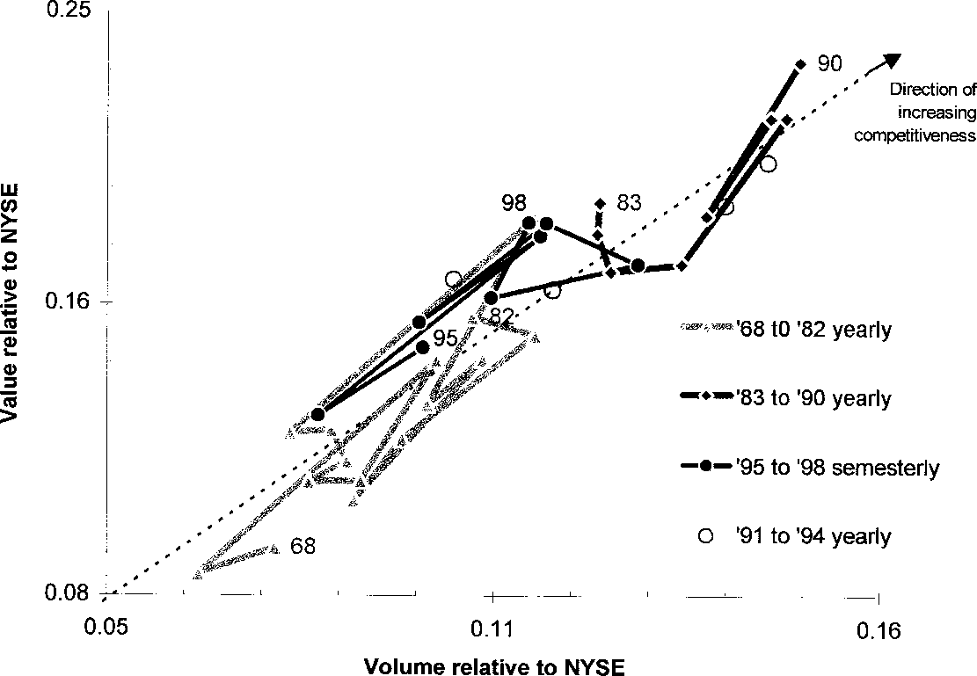

Fig. 2. Three strange attractors (light gray, dark gray, and black line) designate periods of progressively higher return on investments. The dotted line indicates the average price. The excursions above and below the average price (perpendicular distance to the dotted line) are small.

net growth in their competitiveness during this period but the trajectory goes back and forth and is generally confined to this quadrant. At the same time the DJIA stagnates from the investor’s point of view with capital gains for this period practically null (0.4% on a compounded annual basis).
The situation changes during the next seven years. The change coincides with—and is probably due to—the introduction of the electronic intermarket trading system ITS.2 Between 1983 and 1990 the trajectory of the DJIA position oscillates again but this time it is confined to the top right quadrant of the chart, where competitiveness is high. Appropriately, capital gains of the DJIA for this period are high (6.7% on a compounded annual basis). The obvious conclusion seems to be that the introduction of ITS increased competitiveness for the 30 industrials and made them a more profitable investment. This conclusion corroborates the enhanced attention and popularity the DJIA enjoyed in the mid- to late 1980s. O’Higgins’ popular book, Beating the Dow, appeared in 1991 and was probably triggered by the high status of the DJIA during this period. But this is not the end of the story.
The two trajectories we have discussed so far from Figure 2 (light gray and dark gray lines) follow patterns that chaos scientists refer to as strange attractors. An attractor is a point on a surface toward which trajectories are drawn. For example, a simple pendulum can be fully described by two numbers only, velocity, and position. The two-dimensional surface constructed by graphing velocity against position contains all possible situations for a pendulum. One set of values (zero velocity and central position) plays the role of an attractor because all pendulum trajectories spiral inward toward this point as the pendulum slows down in its swinging process, steadily losing energy to friction. A strange attractor is similar but instead of a purely periodic motion (like that of the pendulum) it also reflects the admixture of chaotic fluctuations. The trajectories in

2 The Intermarket trading System (ITS) today links nine stock-exchange markets together over major cities in the United States.

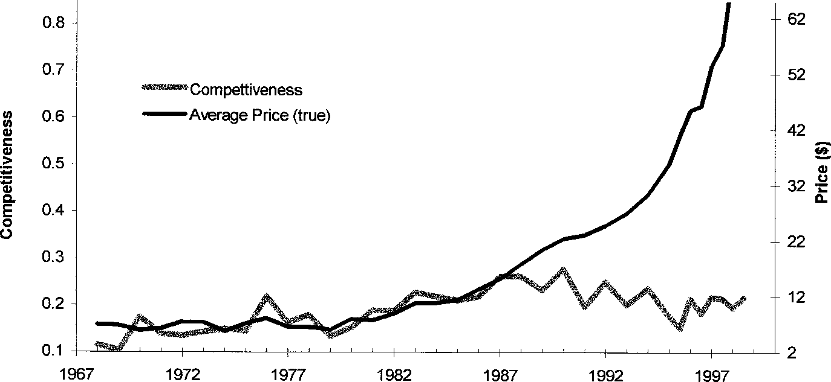

Fig. 3. Competitiveness correlates to price only before 1988.

a strange attractor show some regular (circular) component but are totally mixed up, with random deviations like those encountered in price and currency movements.
From the two time periods 1968–1982 and 1983–1990, one may conclude with good reason that rising competitiveness for the DJIA trajectories entails rising returns for its investors. But things seem different since 1990. There were a few years of erratic movement (1991–1994), and then the DJIA exhibited an intermediate value of competitiveness but an extreme value for return on investments. Figure 2 indicates for the DJIA another yet strange attractor since 1995, in a position intermediate to the two previous ones. But during this time capital returns from the DJIA on a compounded annual basis rose to 9.7%, considerably higher than the gains from the previous period of enhanced competitiveness. It seems that the 30 industrials can finally make their investors happy without having to compete hard for it! However, at the same time, it makes one realize that competitive gains on the stock-market floor may render brokers happier than investors.
To better understand this “maturity” of the Dow Jones let us compare capital gains with competitiveness directly. Figure 3 shows the evolution of the competitiveness and of the true average price, namely, the Dow price corrected for all splits and company substitutions. We observe indeed that competitiveness used to correlate to the price but only up to 1987. The correlation coefficients are R = 0.85 and R = —0.42 for the historical periods before and after 1987, respectively.
A possible interpretation of what we have seen in this section is that the shock of the 1987 crash brought more investors to the Dow Jones thus reducing the necessity for enhanced competitiveness. The 3-year delay in responding (the high-competitiveness attractor of Figure 2 extends to 1990) could be attributed to inertia, that is, the time necessary for this species to sense and adapt to the new conditions.

NYSE’s Most Important Species: The Dow Jones
Populations of cells follow S-shaped patterns as they grow, just as do populations of rabbits. But cell populations can constitute a multicellular organism, which will also grow along S-curves. A group of people linked together with a common goal, interest, ability or affiliation, for example, selling products in order to make a profit; in other words, a company or an organization, can behave as one individual. The individuals

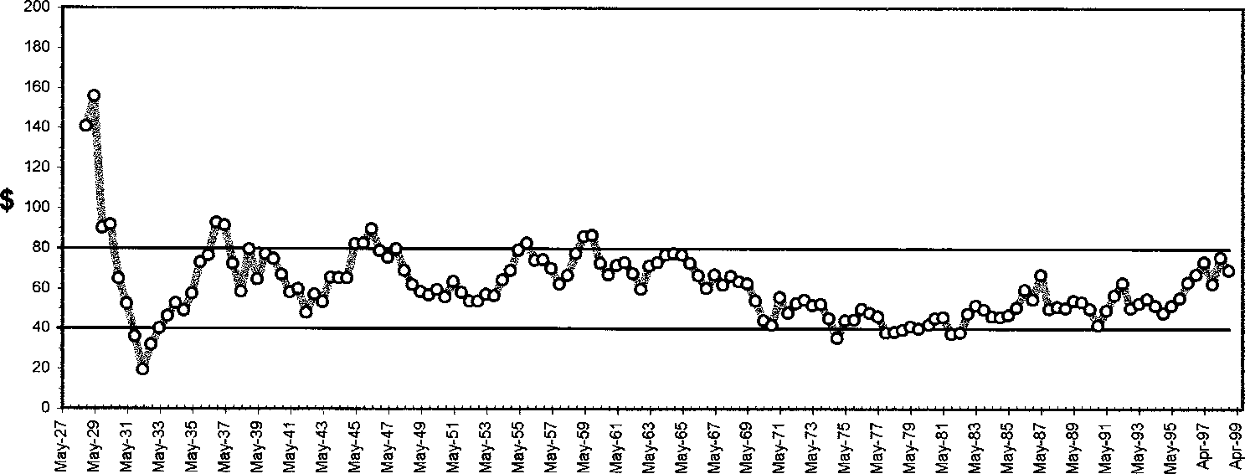

Fig. 4. A simple arithmetic average of the 30 stocks composing the DJIA. The data sampling is every six months. The price has been confined to a narrow band around $60 for more than 50 years.

now play the role of the cells in a multicellular organism, and their assembly becomes the organism. The growth of an organization, therefore, may be expected to follow the familiar S-shaped pattern we have seen for individuals. Raising the abstraction level, we may want to view a group of companies that share much common fate, such as the 30 industrials of the Dow Jones, to behave as a single company, thus also adhering to logistic patterns.
When we study the evolution of a company stock alone, or when we treat the 30 industrials as a single species, we are not ignoring its interactions with the other stocks. We are simply focusing on a macroscopic variable—the overall population—rather than the numerous individuals species-to-species interactions. We are studying one under the influence of all others. This approach takes into account all interactions, but at the same time, it avoids the problem of having to determine the values of 32 million coupling constants.
But what specific variable should we look at to best monitor growth at the NYSE? It is surprising how many variables in fact remain rather invariant over prolonged periods of time. In the next section a number of stock-market invariants are presented more than just for the sake of curiosity. It has been argued that equilibrium and well being may lie behind indicators that do not change with time [13].
  - STOCK-MARKET INVARIANTS
Price is not a physical variable like length, weight, speed, or temperature. It does not obey natural laws. This may be one of the reasons why economics as a discipline does not enjoy the success of other sciences. (The issue has been raised in the Nobel Foundation to abolish economics as a discipline for which a Nobel Prize is given.) Prices in the stock market are even less meaningful than in the marketplace. What do you think was the price of the General Electric (GE) stock one hundred years ago? The answer is $40. Today the GE stock gravitates around $90, not much change in one hundred years, particularly if you take inflation into account. The practice of stock splitting—religiously observed in the NYSE—has maintained the price of each DJIA stock between $25 and $150. But the average price—directly related to the DJIA—has been confined to a much smaller range. The graph in Figure 4 shows a simple average of the Dow Jones industrials calculated as the sum of the prices divided by the number of companies (30), for the last 60 years.

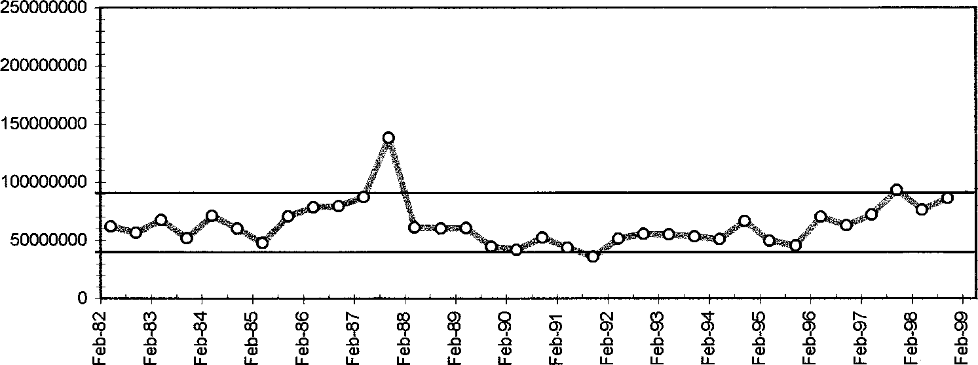

Fig. 5. The true-share volume (i.e., after a correction for splits) of the DJIA. The data sampling is every six months.

Even on the very first day of its existence—on May 26, 1996—the industrial average then based on only 12 stocks was $40.94, a mere 34% below today’s average value.
The remarkable stability of the average Dow price, despite many world-shaking events that took place in the course of the century, characterizes this variable as an invariant. The same phenomenon is true for the other stocks at the NYSE. Stock splitting has also maintained constant the average price of the entire NYSE, but at a lower level. During the last 30 years the average NYSE price has been confined to a band between $25 and $45.
Explanations of the stability of the average prices of the DJIA and the NYSE may involve arguments of convenience connected to the practice of stock splitting. But invariants usually reflect more deeply rooted causes. It wouldn’t be surprising if there were reasons more profound than convenience for this stability, perhaps of cultural origin. After all, stock splitting is a trait somewhat exclusive to the NYSE culture. As for invariants reflecting a state of well-being, the reader’s attention is drawn to the years of economic upheaval around the crash of 1929, when the average DJIA price made excursions well outside—both above and below—the band to which it has been confined ever since. The diminishing-amplitude oscillations following that crash are a hallmark of an autoregulation around a homeostatic level.
The average prices of the 30 industrials, and of the NYSE as a whole, are not the only invariants in the stock market. What would you say if someone told you that the exchange volume of shares of the 30 industrials is also non-varying over time? Impossible? Only if your look at the daily published closing figures. Things look different if you count the number of the real shares (the actual percentage of the company represented by each stock) that change hands every day. Adjusting for stock splits, the number of Dow shares transacted daily remains practically constant.
With exception of the 1987-crash days, Figure 5 shows that the true-shares exchange volume of the 30 industrials has remained rather flat since 1982. In contrast, the closing daily volume grew by a factor of 8 over the same period. But the closing volume is a rather meaningless indicator of what happens over time. It does not represent the same physical quantity as time goes on. Only a correction for splits renders significance to this number by transforming it to a true volume.3 It then becomes invariant, reflecting
3 The true volume is proportional to the closing volume multiplied by the DJIA divisor. A normalization constant can be chosen so that today’s true-share volume is equals today’s closing volume.

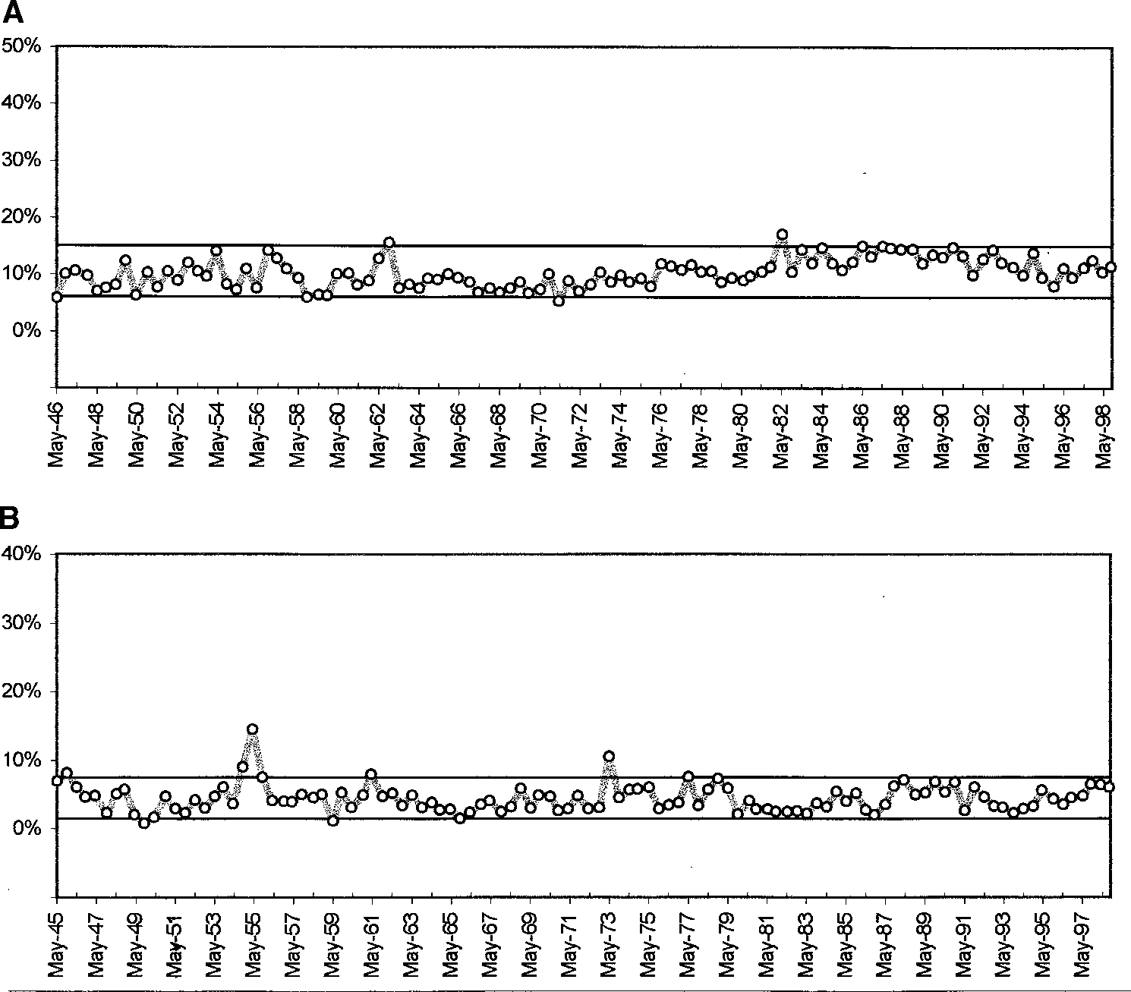

Fig. 6. (A) The daily share volume of the 30 Dow industrials as % of NYSE’s total; (B) the daily share volume of GE as % of the Dow’s total. The data sampling is every six months.

again a homeostasis for the NYSE, or for American society. The “amount” of companies that changes hands every day may fluctuate from day to day but will not drift appreciably over the years. Its average value seems to be dictated by forces with roots deeper than the investors’ hectic running around.
The stability of the true volume shown in Figure 5 has not been eternal. In the 1940s this number was 7 times smaller. Most of the growth took place between 1978 and 1982, and is probably due to the gradual introduction during the same period of the electronic communications network ITS mentioned earlier. This growth of the volume reached a ceiling in the early 1982, and seems to be impervious to further technological advances. It is amazing, for example, that the introduction of electronic trading made possible by the electronic communications networks (ECNs) in 1995 did not result in a significant increase of the true volume. It could be that ECNs trigger growth at a much slower rate than the ITS, and that we do in fact already see the beginning of such a phenomenon with the trend developing at the right-hand side of the curve in Figure 5.
Another way to attach a meaningful-over-time interpretation to the daily volume of shares is to divide this number by the overall volume of shares at NYSE. This fraction is a measure of investors’ preoccupation by the 30 DJIA industrials as whole relative

to all other stocks. It follows from Figure 6A that investors have always paid the same amount of attention to the DJIA.
Figure 6A shows that from the end of World War II, the 30 industrials have been responsible for about 10% of the total volume transacted at the NYSE. Despite fluctuations that could reach as high as 15% and drop as low at 6%, there is no trend visible over half a century. Significant events, like the crash of 1987, did not influence investors’ preoccupation with the DJIA. In terms of probabilities, Figure 6A says that whenever the average investor decides to make an investment, in every 100 shares he or she buys, 10 shares will go to the 30 industrials. This stability confirms the hypothesis that the 30 industrials can be treated as one entity, one well-defined species.
One finds similar stability when taking the ratio of the volumes of one of the 30 industrials to the 30 as a group. If we see the 30 industrials as a niche rather than as one species, we can examine the fraction of this niche occupied by each one of the 30 species, and its evolution over time. In the majority of cases we obtain graphs again indicating invariants, for example, the case of GE shown in Figure 6B. This stability is often true for both share volume and dollar value. Each of the 30 seems to have its own little niche inside the larger niche. Some of them take much space, others take less. Some are more important in value, others more important in volume. But there is a status quo that is generally observed. Like lions and elephants in the jungle, they each have their own turf. Exceptionally short-term trends develop for some of the members and must be addressed individually. But as a rule, and in the long run, if you know what the Dow will do, you know what its members will do.
  - WHAT REALLY GROWS IN THE STOCK MARKET?
With closing stock prices and true-share volumes largely impervious to the passage of time one wonders what is it that really grows in the stock market. The answer can be found in the way the DJIA is calculated. Before October 1, 1928, the DJIA was computed simply by totaling up prices and dividing by the number of stocks. Corrections were applied on a stock-by-stock basis to account for stock splits. But following that date a divisor was established with beginning value 16.67. In other words, instead of totaling up corrected prices and dividing by 30 they simply totaled actual prices and divided by 16.67. From then on, a new smaller value for the divisor has been calculated every time a stock split or a company substitution took place. The divisor has been evolving to ever-smaller values. By the end of 1998 the divisor had decreased to about 0.24.
But dividing by a small number is equivalent to multiplying by a large number. If we think of a multiplier instead of a divisor, its value will be steadily increasing since 1928. Considering that the average price is rather constant, price totals (which equal to 30 times the average price) are also constant and the multiplier’s growth is the DJIA’s growth. The evolution of the DJIA in the long term depends solely on the multiplier. Moreover, the pattern that the multiplier follows as it grows reveals that we are dealing with natural growth in competition (see Figure 7).
We can discern four cascading S-curves in Figure 7A. But we can also zoom back to perceive the beginning of only one large S-curve covering the entire range. Alternatively, we can zoom in closer to discern half a dozen smaller S-curves, inside the first one (see Figure 7B). We have here a practical manifestation of the fractal aspect of logistic growth [14]. But now the issue becomes intriguing because S-curves are endowed with predictability, and if you can predict the multiplier, you can predict the Dow.

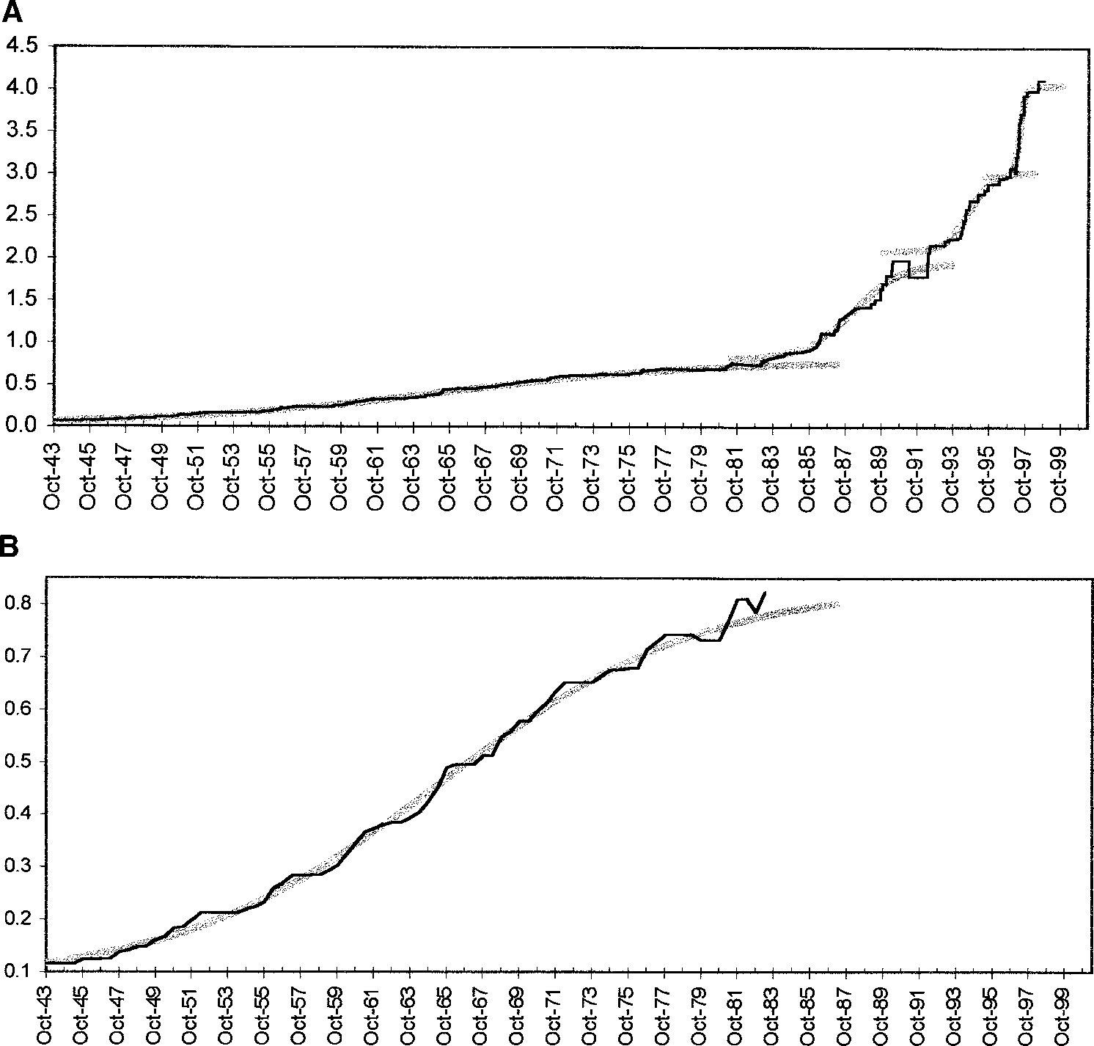

Fig. 7. The evolution of DJIA’s multiplier (inverse of divisor) with data samples every six months.
(A) The last 55 years consists of four S-curves; (B) an expanded view of the first 40 years reveals six smaller S-curves, the first four rather regular.

  - PREDICTING THE DOW
To obtain a rough long-range forecast for the DJIA, one can fit an overall logistic curve on the multiplier data of Figure 7A and then calculate the DJIA by multiplying the fitted curve with 30 × 60 (taking $60 to be the non-varying average Dow price). The result is shown in Figure 8. It says that between 1995 and 1998 the DJIA grew too rapidly when compared with the logistic trend, the law of natural growth in competition. Naturally, the first question that comes to mind is, how much can we trust this forecast? After all, the assumption that the average price for the 30 industrials is constant introduces large uncertainties, and the goodness of the fit over the full range of the multiplier data to a single logistic cannot pass any quantitative test of acceptance. There are reasons to question whether a logistic fit is appropriate in the first place. The multiplier’s growth is only an artifact of stock splitting, an arbitrary practice particular to NYSE (other stock markets in the world do not adhere to this practice with the same fervor). Furthermore, the multiplier as a monitoring variable is no more physical than the price, it does not constitute a limited resource, and can hardly be considered

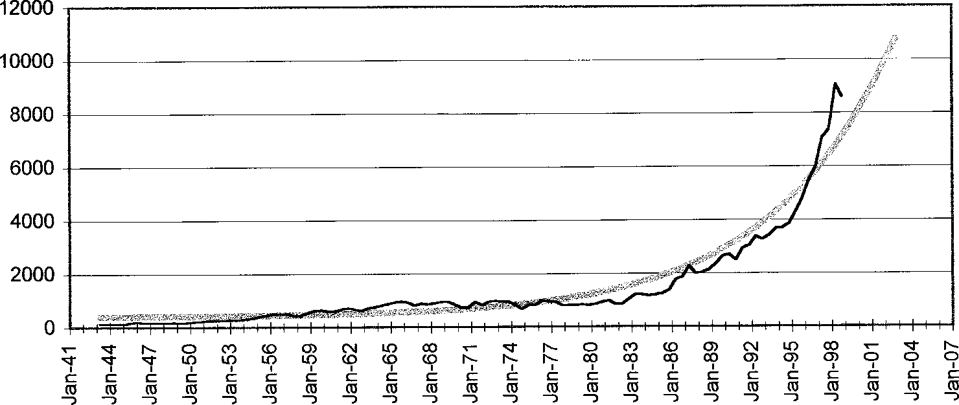

Fig. 8. The black line represents closing values for the DJIA. The data sampling is daily. The thicker gray line is a description following a logistic fit on the full range of the multiplier data. It seems that the DJIA has grown too rapidly in recent years.

a “species.” It seems that the only argument in trusting the forecast of Figure 8 is that the multiplier’s evolution depicts a tendency to follow logistic patterns, on several time frames, and over prolonged periods of time.
But an argument can be made in favor of indirectly seeing the multiplier as a physical quantity and a limited resource. The multiplier is proportional to the ratio closing volume over true volume. Considering that the true volume is almost invariant at the NYSE (see earlier discussion), implies that the multiplier is proportional to—and consequently as physical as—the daily closing volume.
Still, the forecast of Figure 8 is rather crude, meaningful only qualitatively, and in the long term. Near-term forecasts with this approach would carry large uncertainties.

Medium-Term View
We saw earlier that one can treat the Dow as a single species and analyze its population growth in terms of logistic curves. To forecast the DJIA one must fit an S-curve to the historical evolution of the total volume, and independently another one to the total value exchanged over the 30 industrials. The volume here must be the true- share volume; that is, the volume corrected for stock splits. This way the ratio of the two S-curves yields the DJIA directly. We do not need to correct value for stock splits because the factor that corrects volume is equal to the inverse of the factor that corrects price.
Figure 9 shows a medium-term description for the DJIA obtained by fitting data on a historical window covering the last ten years. The trend forecasts low growth in the near future with a possible decline during the early 21st century. The description of the DJIA is better now than in the longer-term view of Figure 8, but still misses sizeable excursions, up or down, and in particular, the market correction and its subsequent recovery in September 1998.
The model description does fair justice to the general trend of the DJIA. But the reader should bear in mind that the trend shown does not really model the published DJIA. By construction—that is, by taking the ratio of value over volume—the model refers to a price average weighted by the share volume, whereas the published DJIA is based on a simple arithmetic average of the price. The two averages go generally hand

T. MODIS

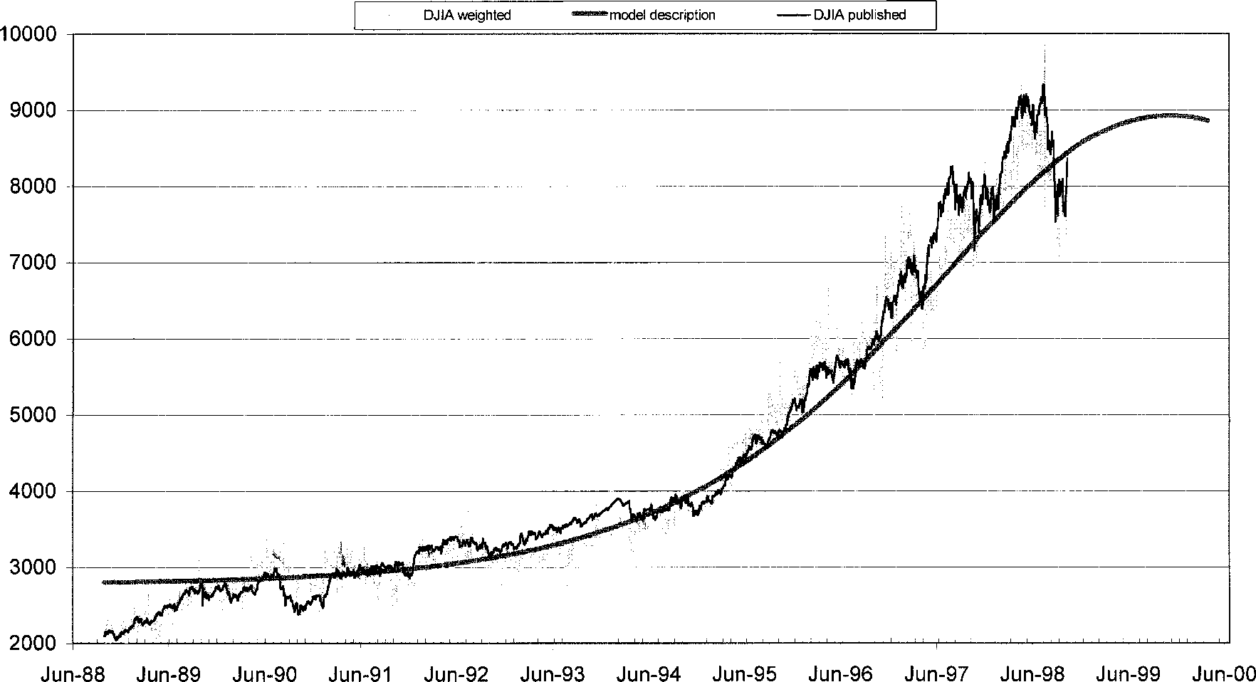
Fig. 9. A study made on October 17, 1998. The irregular thin black line represents official daily quotes for the DJIA. The more irregular gray line represents DJIA as calculated via a volume-weighted price average. The thick smooth gray line results from the ratio of two logistic fits on data, one on true volume and one on value, over the last ten years.

in hand, even if the weighted average fluctuates more widely. Whereas the forecasts on value and volume generally carry small errors, the error on their ratio (the DJIA) can be large. Therefore, frequent updating of the forecasts is recommended for long- term as well as for short-term views.

Short-Term View
To describe major peaks and troughs in the DJIA, one needs to consider a shorter historical window. For example, restricting the historical window to fifteen months, July 1997 to October 1998, gives a description that closely follows the stock market through its dip and subsequent recovery in September 1998. In Figure 10 we see the model description, as well as the constituent logistic fits on true volume and value. The chi square per degree of freedom indicates confidence levels of 94% for the value fit and 51% for the volume one. The goodness of these fits is representative of all other fits in sections 4.3.1., 4.3.2., and 4.3.3.

Exploring Predictability—An Exercise
It is useless to predict something after it has happened. And yet, it constitutes a favorite exercise among forecasters to stop history short and predict the remaining historical data, in an attempt to demonstrate the power of their method. Shrewd businesspersons will simply not buy into such conclusions. It is nevertheless tempting—for academic curiosity, if for no other reason—to investigate here whether this approach could have produced an early warning for the market dip of the summer of 1998. The analysis is repeated four times below, progressively deleting more and more data from recent history.
From the third graph in Figure 11 (panel C) we see that this method could have given close to two weeks warning for the downturn that began on July 21 and shook stock markets worldwide for about two months. On June 16 the forecast was still indicating continued growth (A), but a week later the future trajectory looked flat (B). On July 8 the forecast indicated an imminent sharp downturn (C) despite the fact that the DJIA was still on a bullish path. Three weeks later, with the market on a menacing bear trend, the forecast already promised a turnaround with an inflexion point in late August (D).
As was the case with the bottom graph of Figure 10, (panel C), here too the model description does better justice to the weighted DJIA, not shown in Figure 11 to avoid cluttering.
Combining all results of Section 4.3. we can say that according to this approach, the DJIA’s impressive growth over the last few years seems to have come to an end. A declining rate of growth points to the DJIA stagnating around the 9500 level for a year or so. As with every period of stagnation, large fluctuations of up to ±15% would be compatible with the chaotic character of such a “winter” season [15].

Beyond the Simple Logistic
Company stocks is not the only alternative investors have at the NYSE. Bonds, futures, funds, options, warrants, and many other instruments also elbow each other for investors’ attention and money. Traditionally bonds have been the most popular less risky alternative to stocks. Let us concentrate on stocks and bonds, these two most significant “generic species” of the stock market, arguing that they constitute a niche of their own. Under this assumption we may want to understand their detailed interaction.4
4 The assumption here is less defensible than it was for stocks alone, because investors who buy bonds may not stay away from funds, whose presence at NYSE has become increasingly important in recent years.

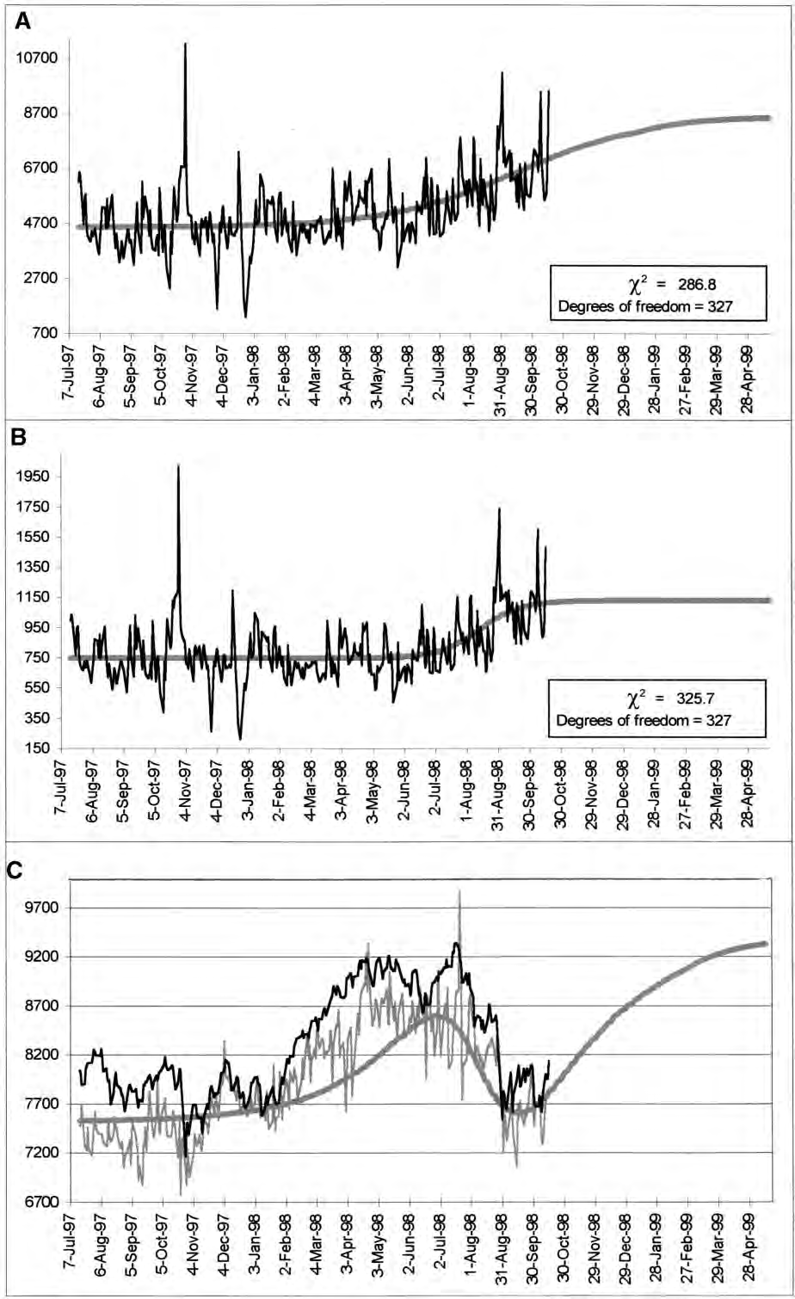

Fig. 10. A study made on October 17, 1998. The irregular thin black line represents official daily quotes for the DJIA. The more irregular gray line represents DJIA as calculated via a volume-weighted price average. The thick smooth gray line results from the ratio of two logistic curves determined in the top two graphs. (A) Value fit. (B) True-volume fit. (C) A short-term analysis.

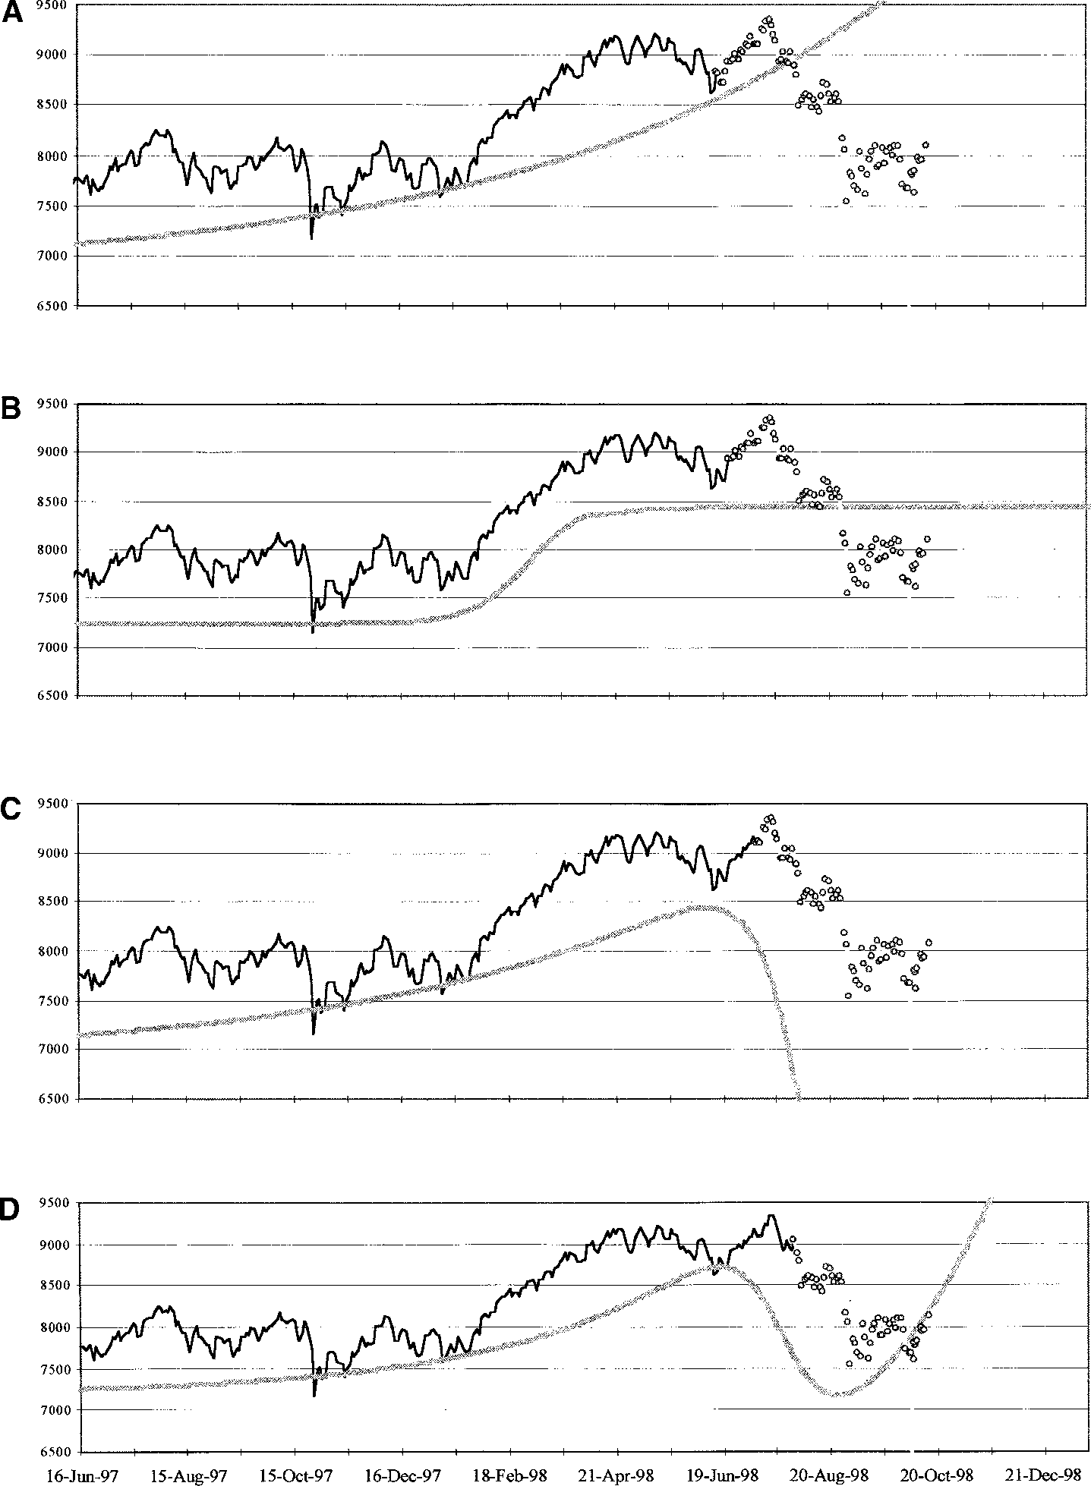

Fig. 11. (A–D) Four graphs with forecasts (gray lines) at different times, approaching the major market correction of the summer of 1998. The small circles show the subsequent evolution of the actual DJIA (black lines). The decline is anticipated by two weeks (C), the bottoming out by more than a month (D).

TABLE 1
Signs c_{xy} and c_{yx} Determine the Type of Competitive Roles
cxy cyx | Type | Explanation
—— | Pure competition | Occurs when both species suffer from each other’s existence
+— | Predator-prey | Occurs when one of them serves as direct food to the other
++ | Mutualism | Occurs in case of symbiosis or a win-win situation
+ 0 | Commensalism | Occurs in a parasitic type of relationship in which one benefits from the existence of the other, who nevertheless remains unaffected
— 0 | Amensalism | Occurs when one suffers from the existence of the other, who is
impervious to what is happening
0 0 Neutralism Occurs if there is no interaction whatsoever

  - MATHEMATICAL FORMULATIONS OF THE VOLTERRA-LOTKA SYSTEM OF EQUATIONS
The interaction between two competitors can be expressed in general terms via
the introduction of two coupling constants c_{xy} and c_{yx}, which are used to transform the simple logistic equations into the Volterra-Lotka coupled differential equations:
dX = a_{x}X — b_{x}X² + c_{xy}XY
dt
dY = a_{y}Y — b_{y}Y² + c_{yx}YX
dt
This system of equations contains all fundamental parameters that impact the rate of growth. Namely, the capability of each species to multiply a, the limitation of the niche capacity b related to the niche size, and the interaction with the other species c. The signs of c_{xy} and c_{yx} determine the type of competitive roles, see Table 1.
Pielou has recast the solutions of this system of differential equations into a system of difference equations [16]. The new system can now be solved via numerical iterative techniques. To use Pielou’s formulation, we need to introduce a number of new constants λ_{x}, β_{x}, λ_{y}, β_{y}, A, and D as defined below:
X(t + 1) = λx X(t)
1 + β_{x}X(t) — A β_{x}Y(t)
Y(t + 1) = λy Y(t)
1 + β_{y}Y(t) — D β_{y}X(t)

where λ= ea and
b(ea — 1)
β= a
for X and Y and

A = cxy
β_{x}
D = cyx
β_{y}

Under the assumption that X is the incumbent and Y the attacker, the parameters A and D can be interpreted as the attacker’s advantage, and the defender’s counterattack respectively.

TABLE 2
Parameter Values
 | A | B | C
Stocks | 0.99 | —0.008 | 2.66
Bonds | 2.02 | —0.00004 | 0.001

Carl Pistorius and James Utterback have explored the use of phase diagrams, X(t) versus Y(t), where directional derivatives can indicate preferred directions for action [17]. This subject needs further study and development toward practical applications.
The above two-competitor formulation can be generalized to n competitors. The new system of equations in discrete form will be as follows:

n n
Χ ^{i}_{n+1} = α_{i} · Χ ^{i}_{n} + Σ Σ β_{ij} · Χ ^{i}_{n}· Χ ^{j}_{n}
i = 1 j = 1

where α_{i} and β_{ij} are constants.
In this generalized form the Volterra-Lotka equations can account for all phenomena in an ecosystem including chaos, extinction, and other ramifications of complexity.
  - STOCKS EXCHANGED VS. BONDS EXCHANGED
We will examine data that span thirty years worth of history by dividing them into two periods punctuated by the crash of 1987. The decision to split history in this way was motivated by reasoning that a stock-market crash is likely to provoke increased mutations and interfere with the determination of competitive roles.

Before 1997
Fitting the data before 1987 with the above formulation of the Volterra-Lotka equations gave the parameter values shown in Table 2.
The fact that the coupling constants are both positive indicates a symbiotic, if asymmetric, relationship. It says that stock sales benefit much more from bond sales than the other way around. However, this win-win situation is not all carefree. The benefit of stocks is so large that it masks a parasitic aspect in the evolution of stocks. Stocks do not quite have the ability to multiple on their own, a is somewhat smaller than 1. If the bond exchange volume were suddenly to become zero, the stock exchange volume would also decline eventually and wither away! On the contrary, if the stock volume were to become zero, the bond volume would continue to grow, if at a slower rate.

After 1997
As suspected the crash of 1987 perturbed the relationships and the roles. Fitting the equations to the data after 1987, we obtain a positive-negative combination of coupling constants, that is, a predator-prey relationship with stocks playing the role of predator. It means that stocks benefit from bond growth but bonds suffer from stock growth. The negative impact of stocks on bonds may be a small number but due to the high stock volume it causes the bond population to diminish with time (see Figure 12). Surprisingly, despite the fact that stocks “feed” on bonds, their survival does not depend on bonds’ existence. The positive coupling constant is not as large as it was before 1987, and the multiplication capability of stocks has improved, so that even in the absence of bonds they would be able to continue growing, if at a reduced rate. Needless to say, bonds would grow rapidly in the absence of stocks (Table 3).
It is interesting to look at the crash of 1987 from this angle. The crash twisted a happy coexistence between the stock and the bond exchange markets into a ferocious

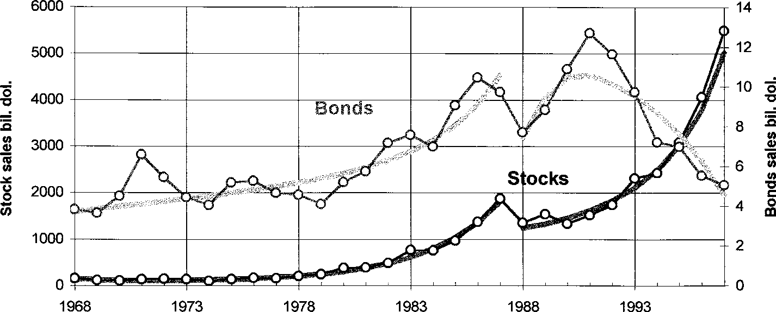

Fig. 12. The two historical periods 1968–1987 and 1988–1997 have been analyzed independently using the Volterra-Lotka equations. A win-win relationship before 1987 has been transformed to predator prey in favor of stocks.

strife of the hare-lynx type. Moreover, it strengthened the stocks “genetically” by increasing their multiplication ability so that now they can survive independently from bonds. If these competitive roles remain unchanged, the bond volume will soon dwindle down to negligible levels. A possible new shock (a significant event in the financial world) could change the roles once again, but if we let 1987 serve as an example, it is not likely that a new crash will bring bonds back into the limelight.

Conclusions
In the stock market one invests money by buying shares. There are shares at different prices. As with products, low prices does not necessarily represent better deals. The existence of competition is beyond doubt. The competitors are all the issues traded on the Big Board. They can be seen as species engaged in a Darwinian struggle for survival of the fittest. They compete for investors’ favor. At the end of a day at the NYSE the success of a stock relative to other stocks competition-wise can best be measured by its two market shares: the percentage of total NYSE share volume, and the percentage of total NYSE dollar value.
The arguments in favor of treating the stock market as an ecosystem, and company stocks as species competing in nature, can be summarized as follows. Looking at stock behavior through the lens of the exchange value and the exchange volume, we realize that:
- There is competition.
- There is selection.
- There is equilibrium (homeostasis).
- There is stability (the NYSE has been growing for more than 100 years; the composition of the 30 industrials rarely changes).
- There are well-defined niches. Total NYSE is one of them, the 30 industrials is another.
If in addition we find that over a certain historical period the trajectories of volume and value are amenable to a description by logistic functions, our hypothesis becomes defensible, and the ensuing price forecasts believable.
TABLE 3
Parameter Values
a b c
Stocks | 1.89 | 0.0010 | 0.069
Bonds | 3.08 | —0.685 | —0.0024

The analysis shows that investments in stocks, and in particular the 30 Dow Jones industrial stocks, have been growing in popularity during the last thirty years. However, gains in competitiveness on the stock-market floor do not necessarily correlate with capital gains. In what could be interpreted as a sign of maturity, the DJIA grew impressively—particularly during winters—in recent years, while enjoying only moderate competitiveness.
But the DJIA forecasts indicate that growth in the NYSE will slow down in the coming years. Despite the increased popularity of stock investments, and the aggressive way they displaced bonds during the 1990s, the Dow Jones should be hovering at approximately 9500—probably accompanied with large erratic excursions above and below this level—until the year 2000.5 Such a “pessimistic” forecast for America’s major stock exchange receives credibility from the fact that for some time now spending exceeds earning in the American economy [18]. Americans will sooner or later be forced to cash in their gains in the stock market to cover their spending, which precludes continued growth of stock prices.
The approach seems to yield a better grip on real trends than approaches based directly on the price. The exercise of Section 4.3.3. not only anticipates a coming decline but it also estimates how serious the decline will be. The added value in this approach comes from the fact that the variables we are studying—dollar value and share volume— obey the law of natural growth in competition. And that law, like every natural law, is endowed with predictability.
The vulnerability of the approach lies with the fact that price forecasts are obtained via a ratio (dollar value/share volume). Whereas both numerator and denominator can be forecasted reliably, the ratio carries large uncertainties. It is recommended that price forecasts are updated frequently.
One could use the same logistics determined for the DJIA forecasts to obtain forecasts for each one of the 30 industrials. This is possible because each industrial stock generally contributes a fixed, or a slowly varying, amount to the total DJIA exchange volumes. Most forecasts obtained this way would look qualitatively similar, with a certain spread above and below the DJIA trend.
On the other hand, one may want to approach each stock independently and determine a new set of logistics on the evolution of the volume and the value of each. The forecasts obtained in this way will certainly show more stock-to-stock variation. One may thus obtain valuable short-term forecasts, but the long-term analysis would be less reliable than for the DJIA as a whole. It was mentioned earlier that the Dow Jones is less mutable a species than the individual companies that compose it.
In any case, the approach provides a new, unique, and science-based way of anticipating trends and obtaining insights in the stock market.

5 At the time of this manuscript’s last revision the DJIA had surpassed the 10,000 mark. In the author’s opinion this event constitutes an upward excursion to be corrected—sooner or later—in the downward direction.

References
- Verhulst, P. F.: Recherches mathe´matiques sur la loi d’accroissement de la population, Nouveaux Me´moires de l’Acade´mie Royale des Sciences et des Belles-Lettres de Bruxelles, 18, 1–40 (1845).
- Lotka, Alfred J.: Elements of Physical Biology. William & Wilkins Co., Baltimore, MD, 1925.
- Volterra, Vito: Lec¸ons sur la the´orie mathe´matique de la lutte pour la vie. Gauthier-Villars et Cie, Paris, France, 1931.
- Leslie, P. H.: A Stochastic Model for Studying the Properties of Certain Biological Systems by Numerical Methods, Biometrika 45, 16–31 (1957).
- Pielou, E. C.: An Introduction to Mathematical Ecology, Wiley Interscience, New York, NY, 1969.
- Odum, E.: Fundamentals of Ecology, Saunders, London, UK, 1971.
- Williamson, M.: The Analysis of Biological Populations, Edward Arnold, London, UK, 1972.
- Smitalova, Kristina, and Sujan, Stefan, 1991: A Mathematical Treatment of Dynamical Models in Biological Science Ellis Horwood, West Sussex, England.
- Marchetti, Cesare: Infrastructures for Movement, Technological Forecasting and Social Change 32(4), 373–83 (1987).
- Modis, Theodore: Genetic Re-Engineering of Corporations, Technological Forecasting and Social Change
56(2), 107–118 (1997).
- O’Higgins, Michael, and Downes, John: Beating the Dow. HarperCollins, New York, NY, 1991.
- Brealey, Richard, and Myers, Stewart: Principles of Corporate Finance. McGraw-Hill, 1981.
- Originally an idea by Cesare Marchetti has been documented in Modis, T.: Predictions. Simon & Schuster, New York, NY, 1992.
- Modis, T.: Fractal Aspects of Natural Growth, Technological Forecasting and Social Change 47, 63–73 (1994).
- Modis, T.: Conquering Uncertainty. McGraw-Hill, New York, NY, 1998.
- Pielou, E. C.: An Introduction to Mathematical Ecology. Wiley-Interscience, 1969.
- Pistorius, C. W., and Utterback, J. M.: The Death Knells of Mature Technologies, Technological Forecasting and Social Change 50(3), 133–151 (1995).
18. The Economist, Nov. 14, 93–94 (1998).

